Western Mathematics Exams

School Name

Half Yearly Examination
2016
Year 10
Advanced Mathematics Course

Solutions
Year 10 |  | WME Solutions  Advanced Mathematics  Half Yearly | Non Calculator
Section 1 Short Answer Section
ANSWERS
No. | WORKING |  | ANSWER
 |  |  | 32
 | 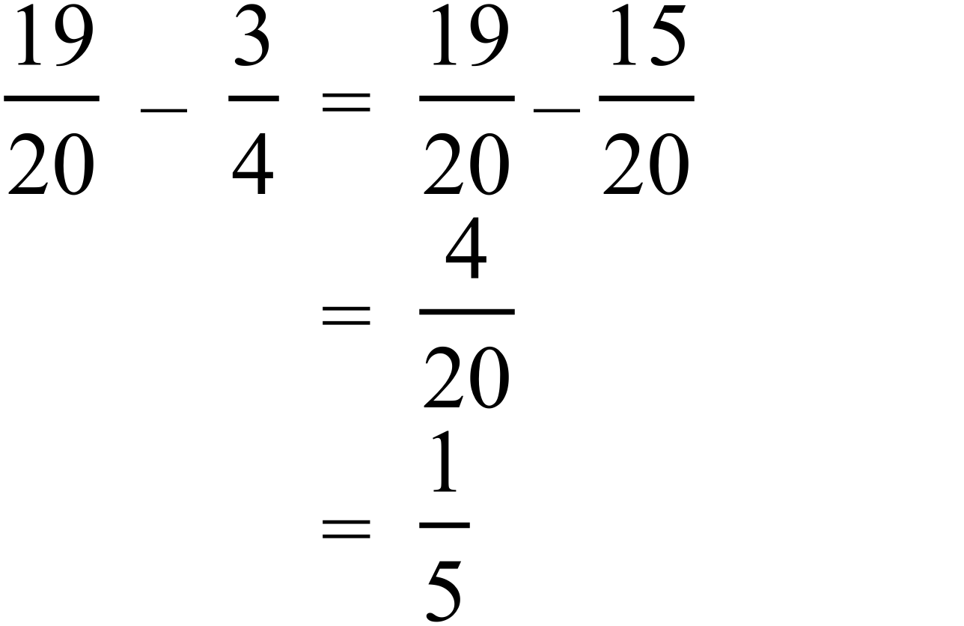 |  | 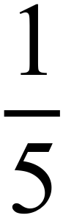
 | 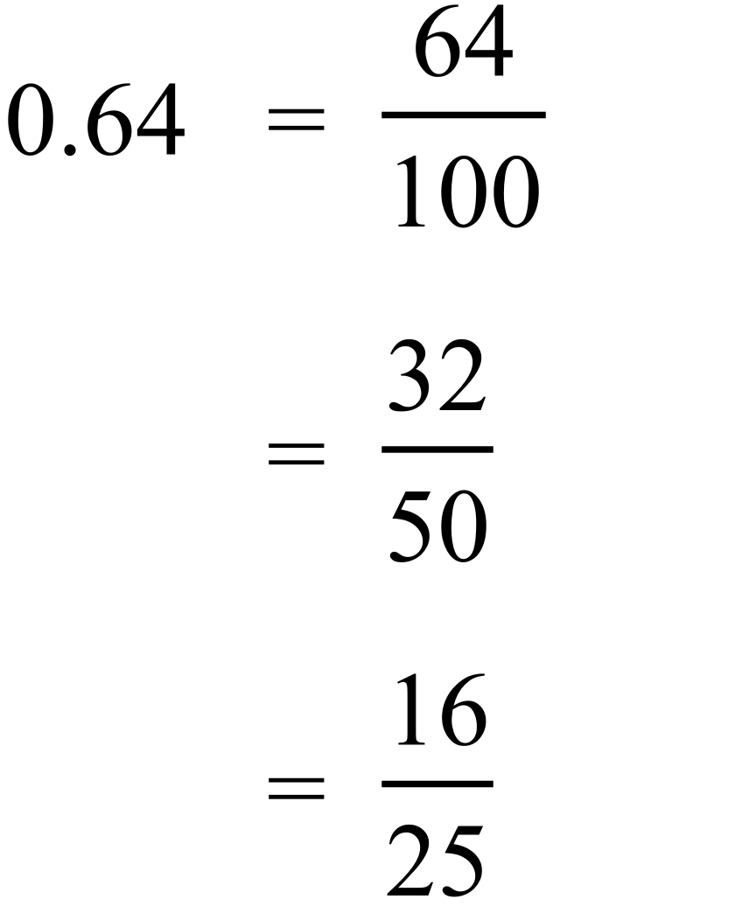 |  | 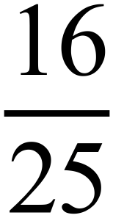
 | From 4 pm to 11 pm is 7 hours.  In 7 hours temp falls 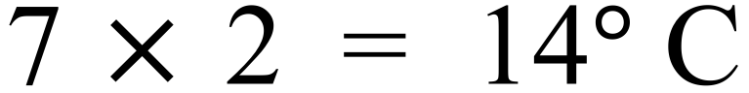  Temp at 11 pm = |  | 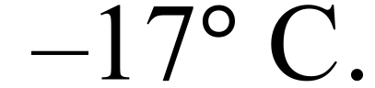
 | 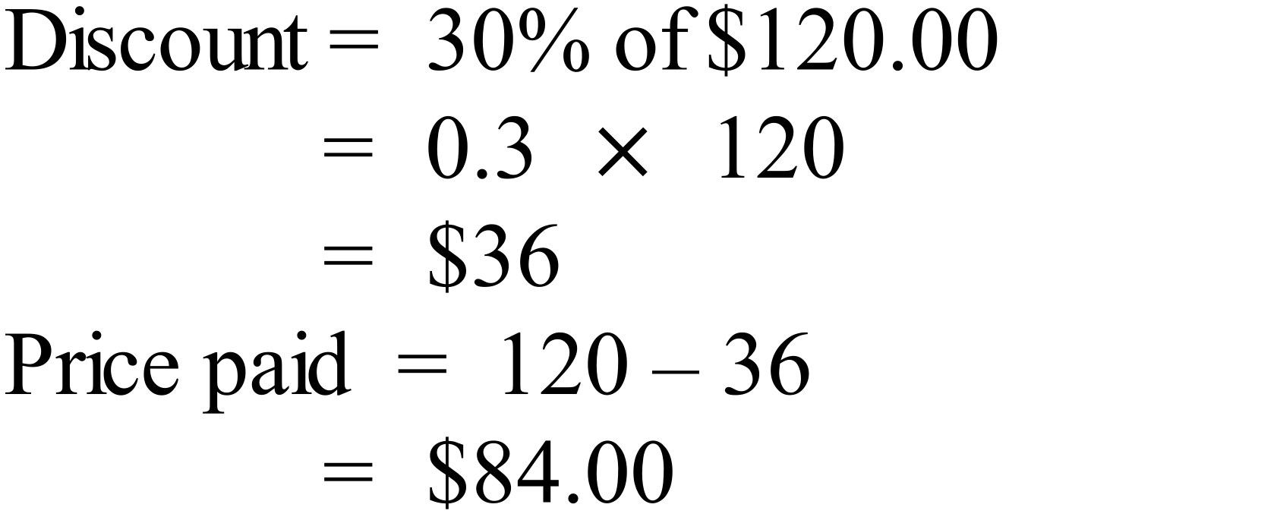 |  | $84.00
 | 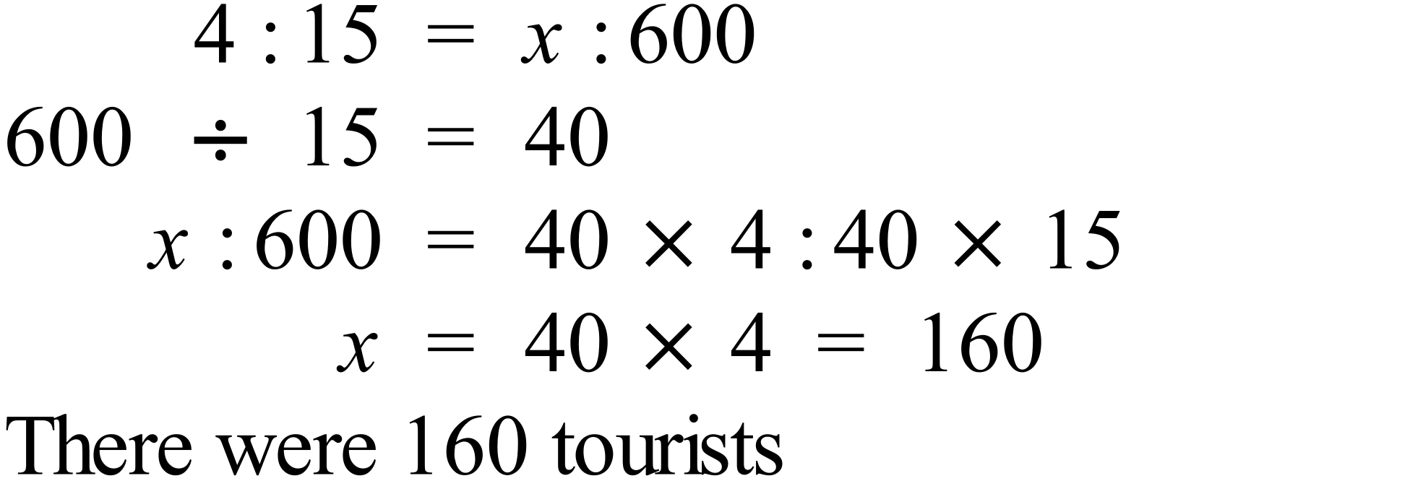 |  | 160 tourists
 | 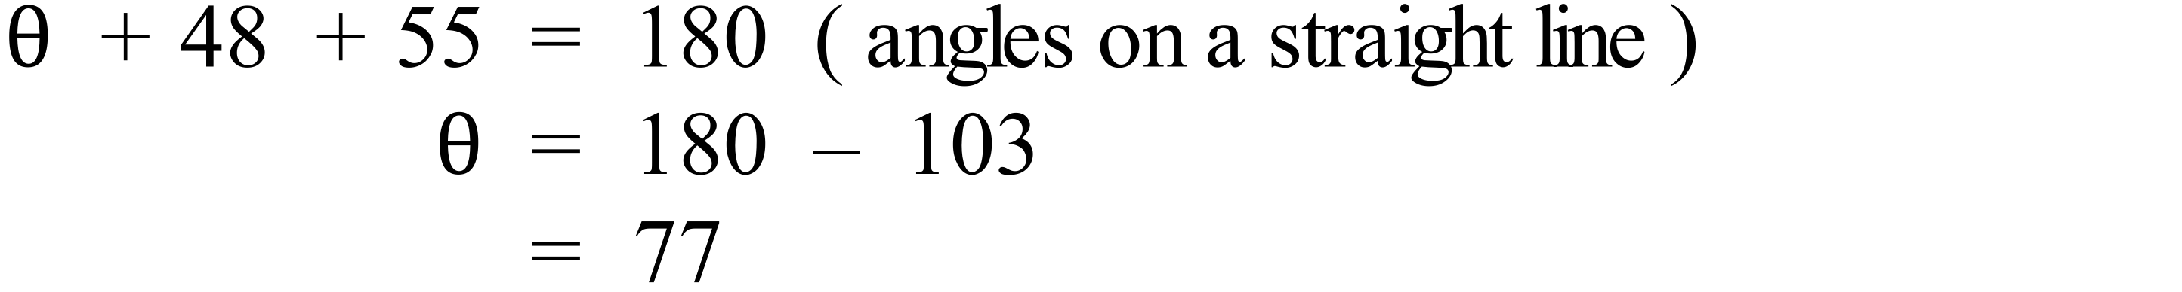 |  | 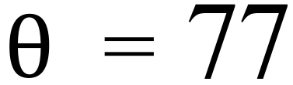
 | 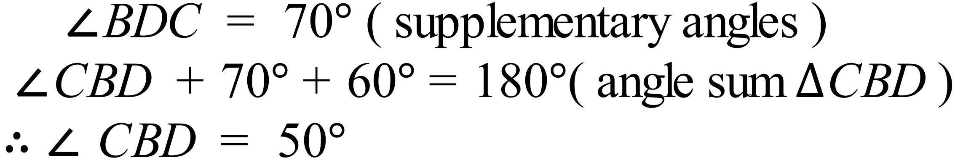  OR  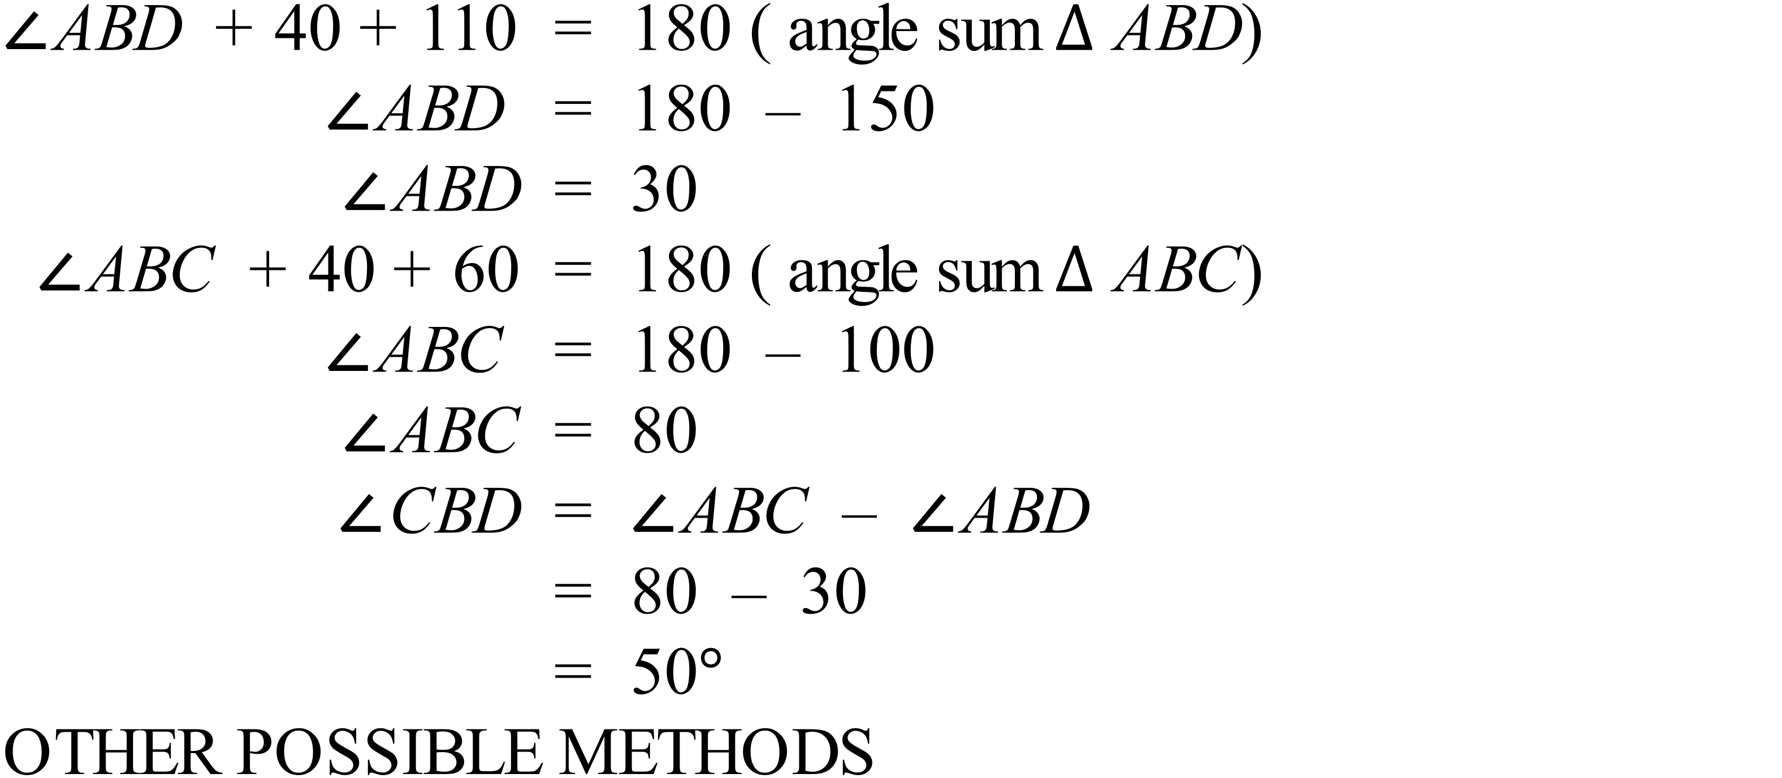 |  | 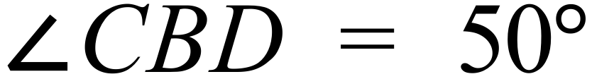
 | 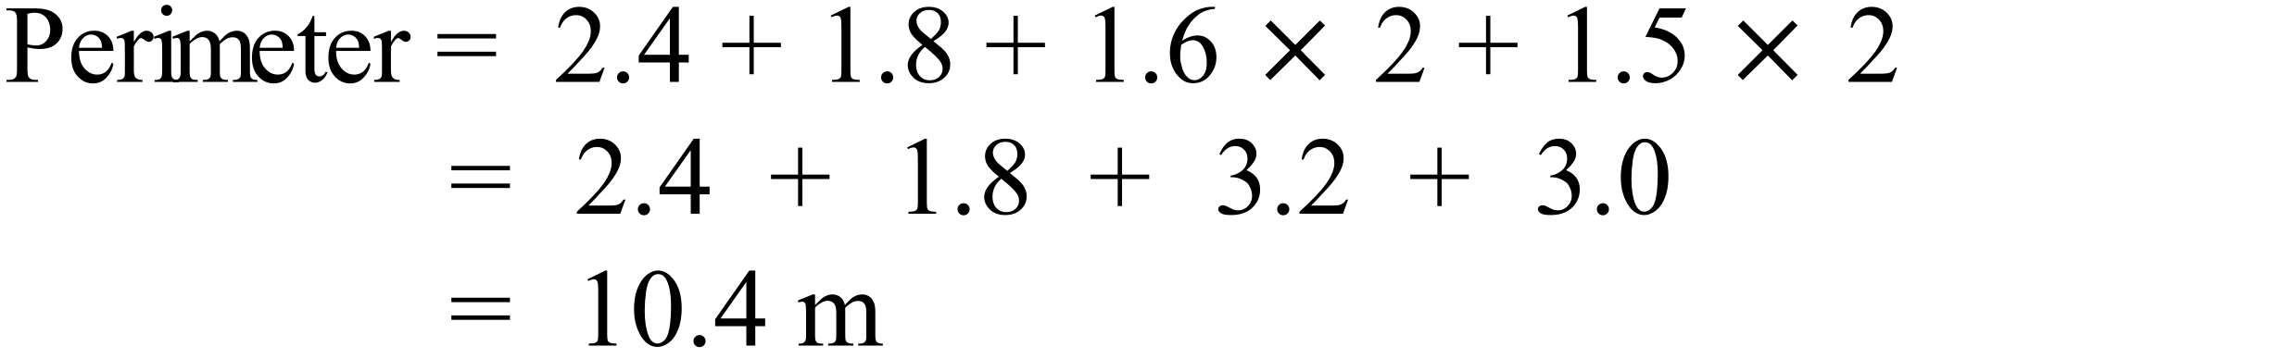 |  | 10.4 m
 | 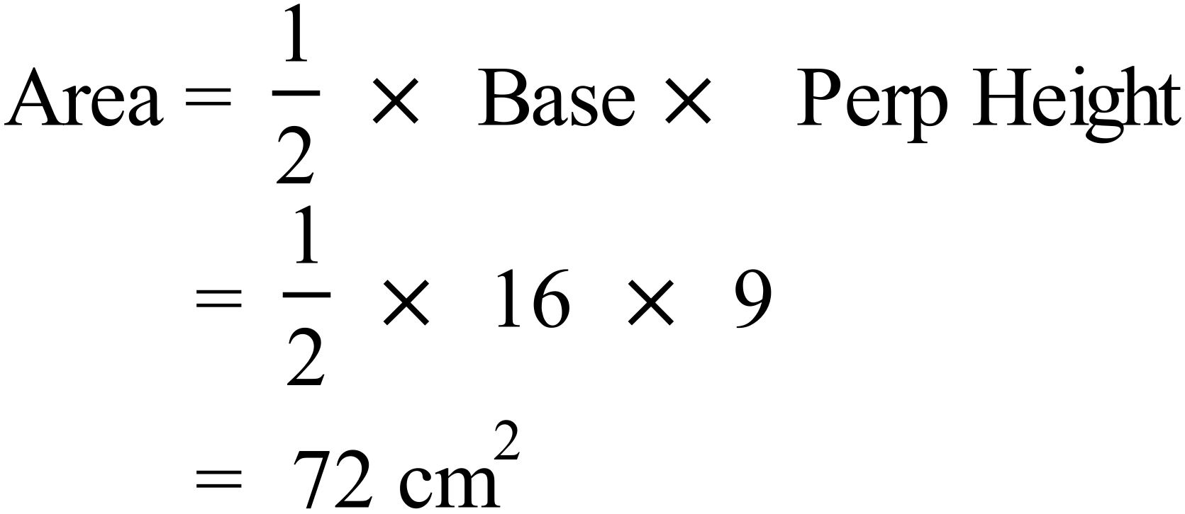 |  | 72 cm²
 | 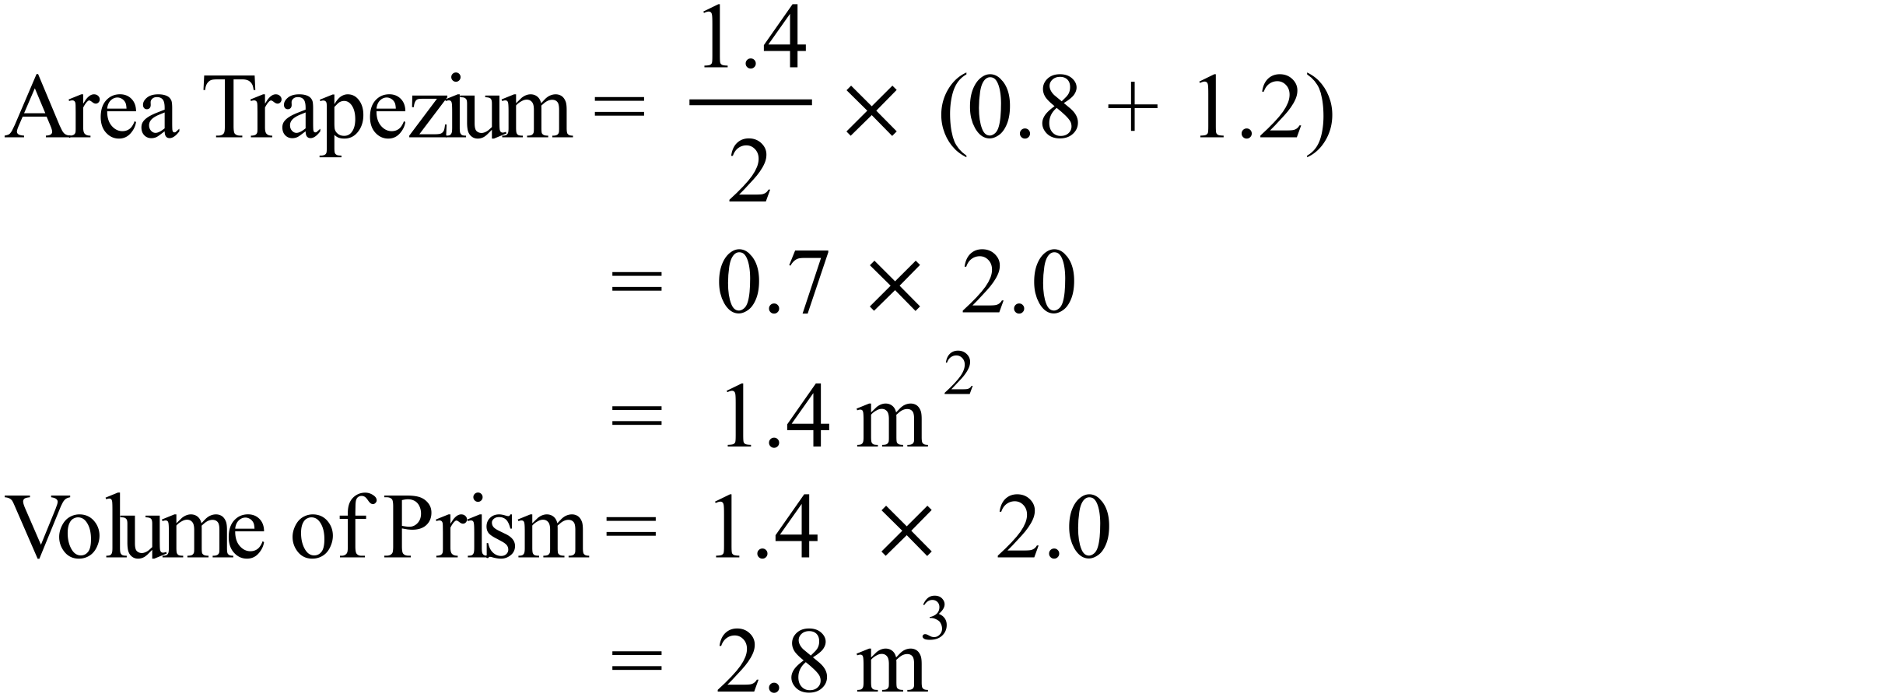 |  | 2.8 m³
 |  |  | 14xy
 | 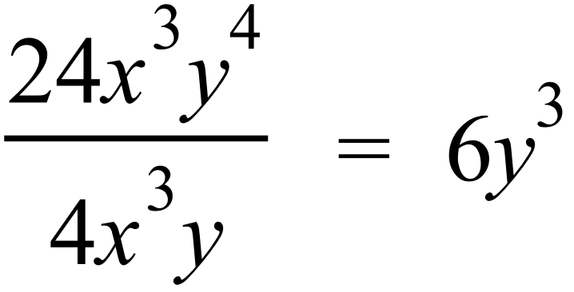 |  | 6y³
 | 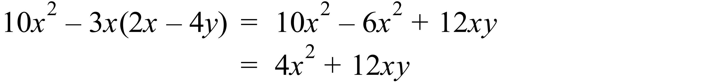 |  | 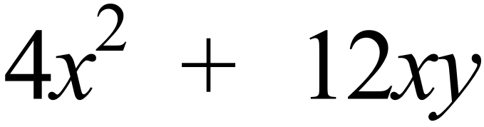
 | 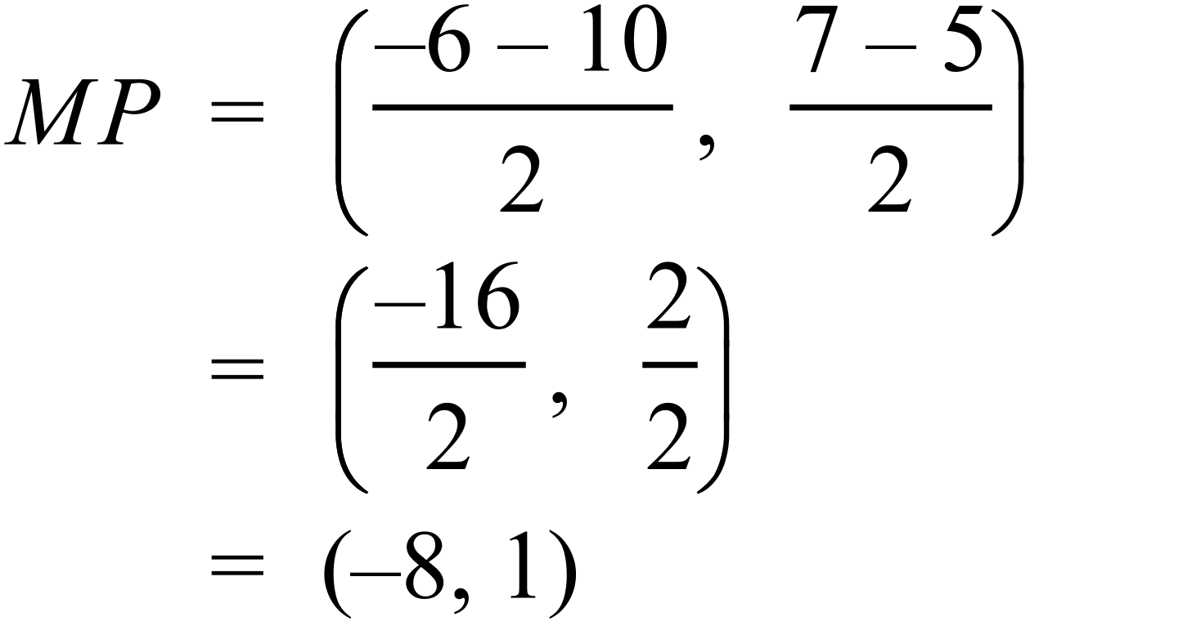 |  | (-8, 1)
 | 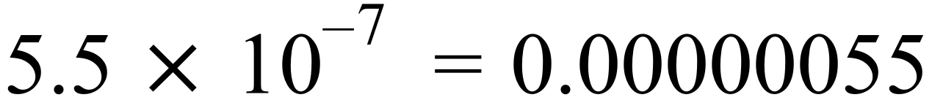 |  | 0.00000055 metres
 | 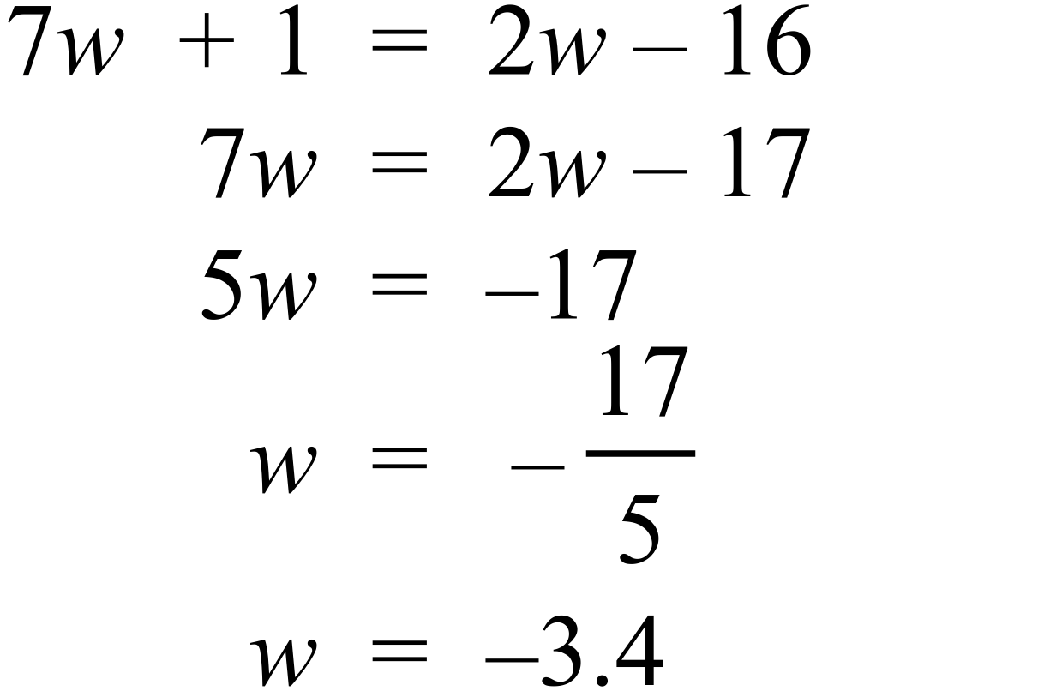 |  | 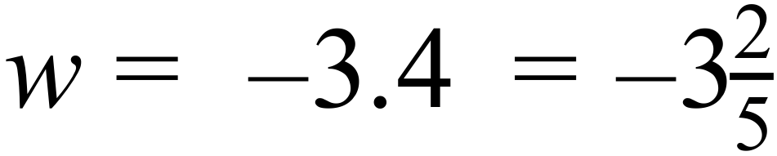
 | 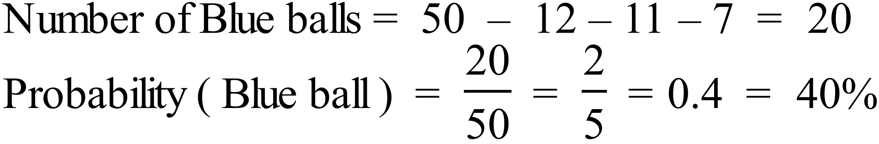 |  | Any of  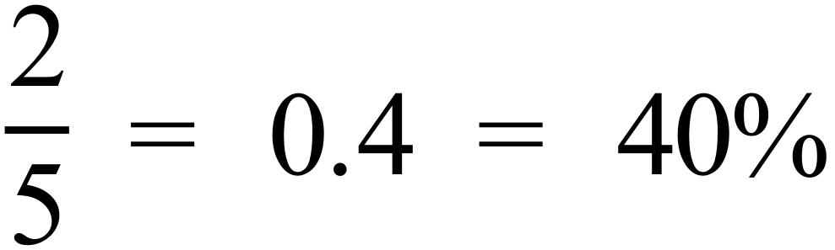
 | There are 7 scores out of 20 which are less than 20.  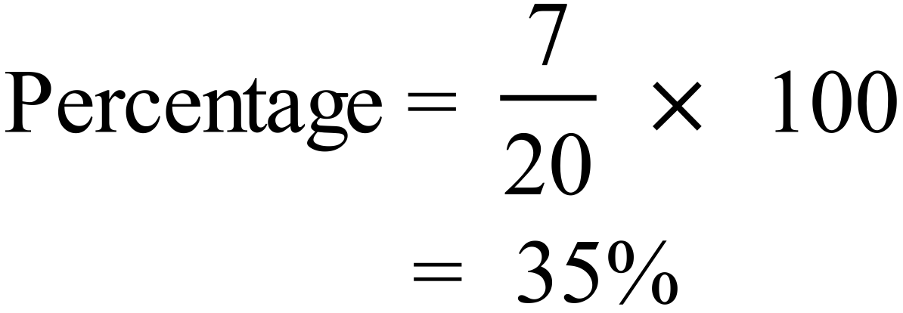 |  | 35%
 | Sum of the scores = 12 + 61 + 122 + 69 + 167 + 107  = 538  Mean = 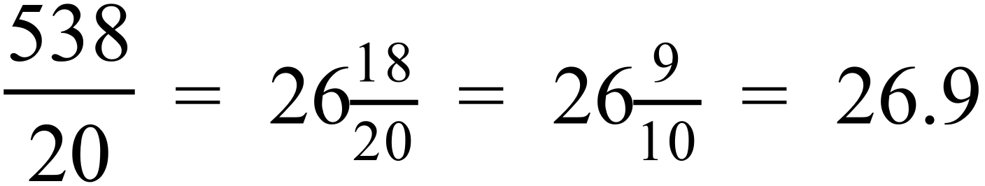 |  | 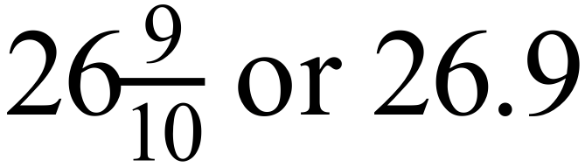

Year 10 |  | WME Solutions  Advanced Mathematics  Half Yearly | Calculator Allowed
Section 2 Part A Multiple Choice Section
ANSWERS
No. | WORKING |  |  | ANSWER
 | 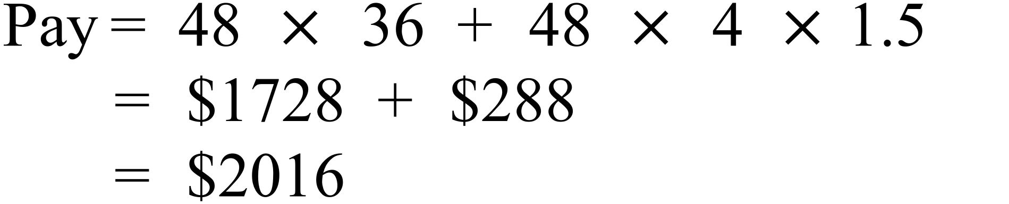 |  |  | C
 | 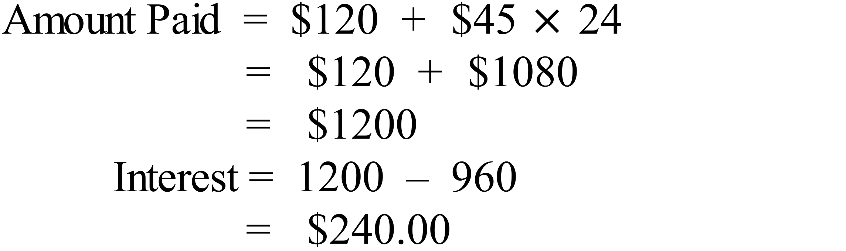 |  |  | B
 | 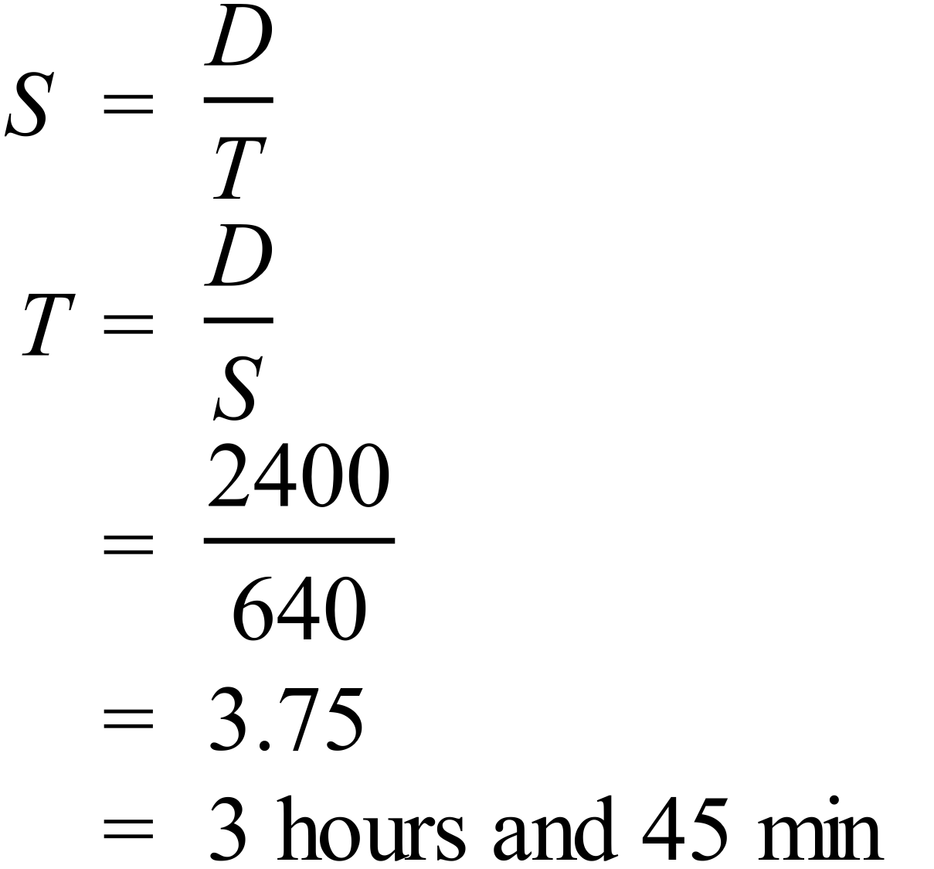 |  |  | D
 | 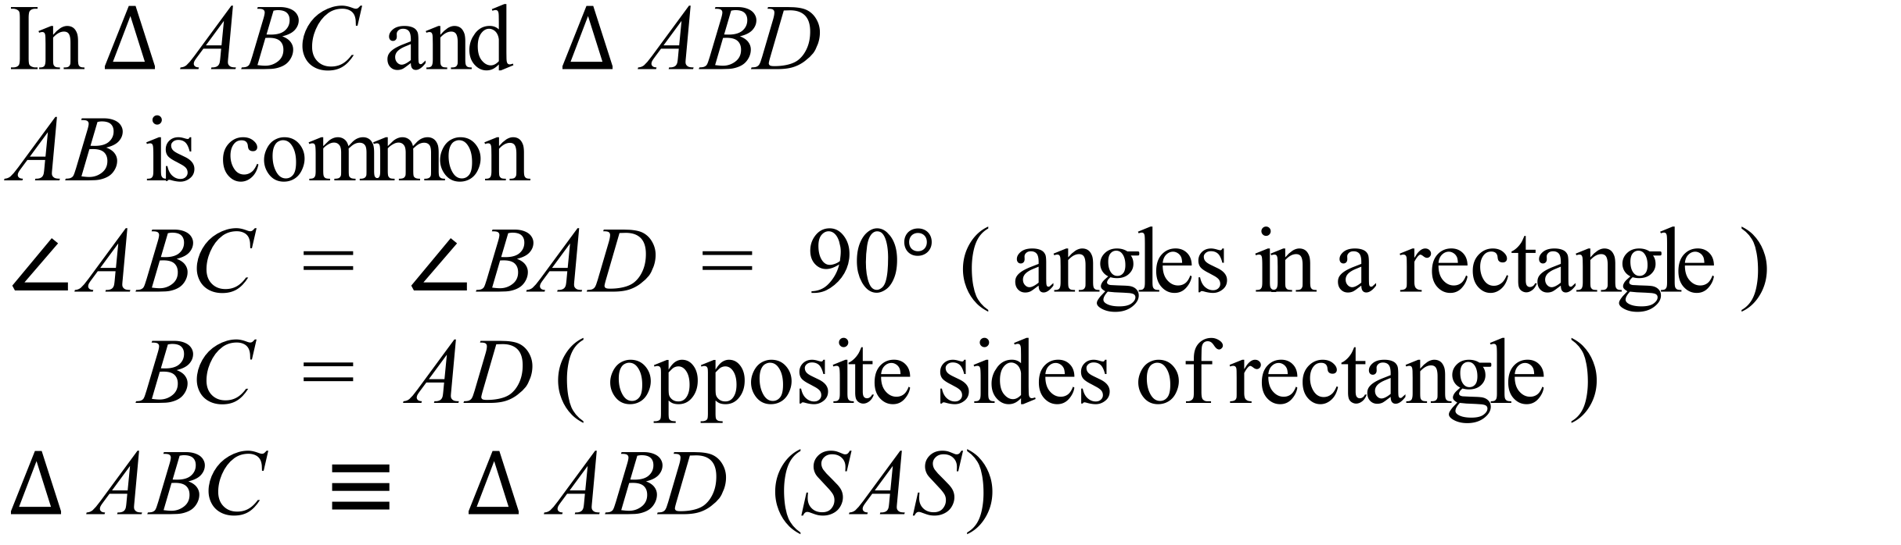 |  |  | C
 | 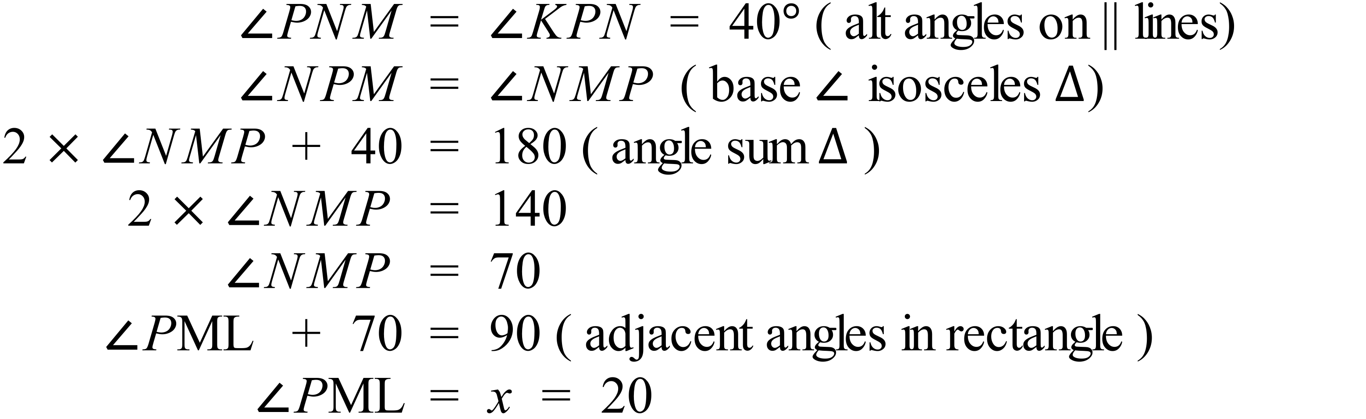 |  |  | A
 | 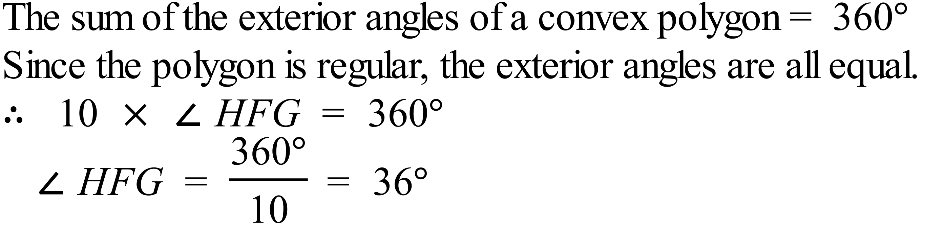 |  |  | C
 | 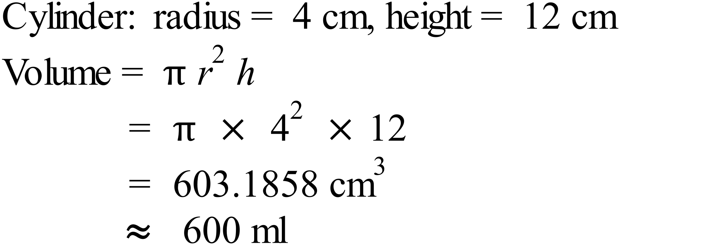 |  |  | B
 | 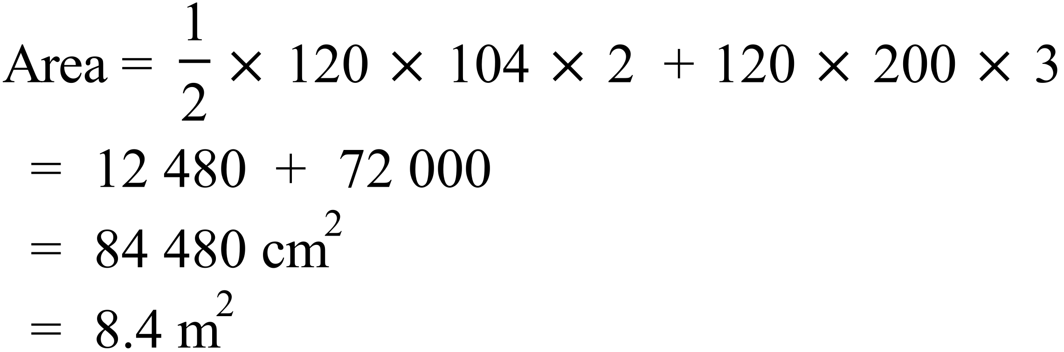 |  |  | D
 | 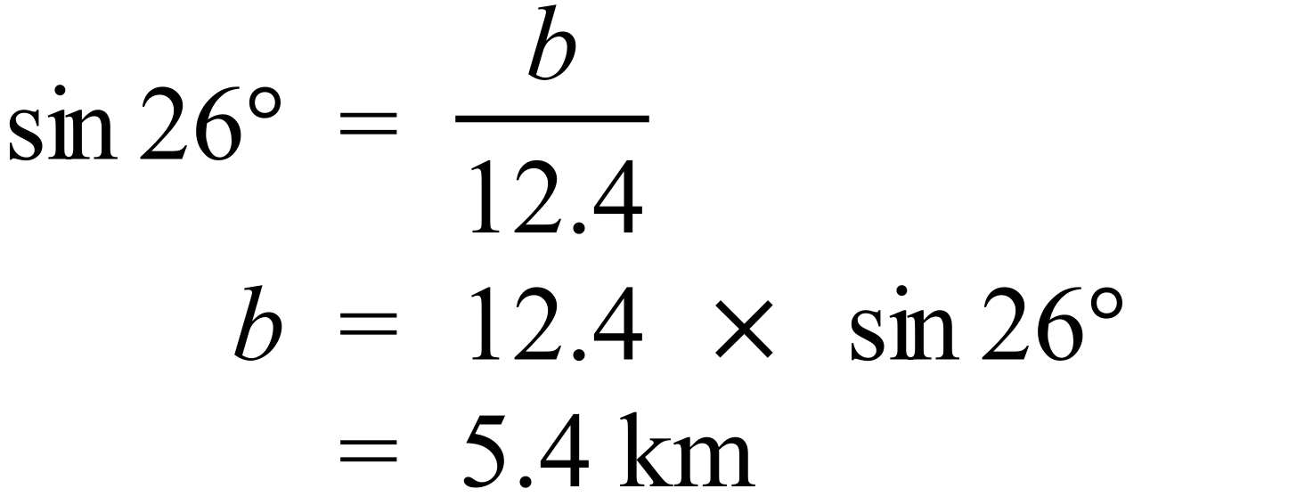 |  |  | A
 | 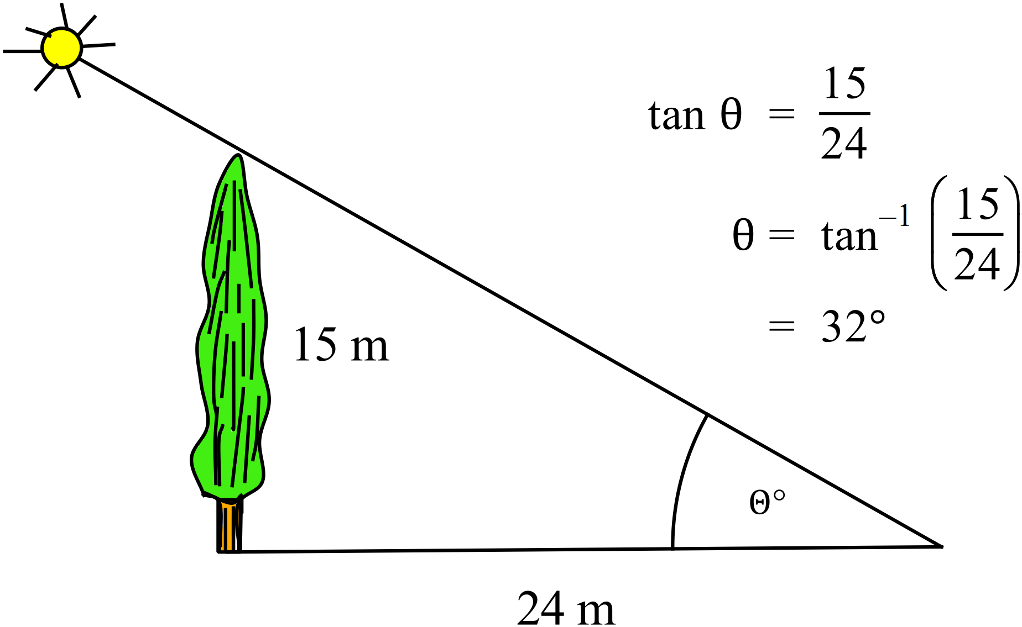 |  |  | A
 | 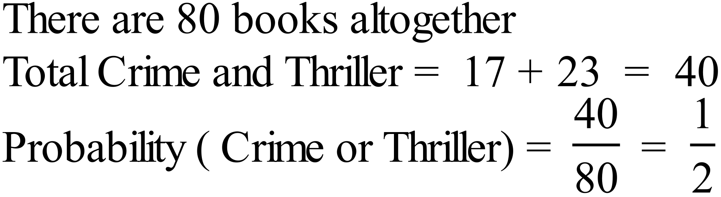 |  |  | C
 |  |  |  | B
 | 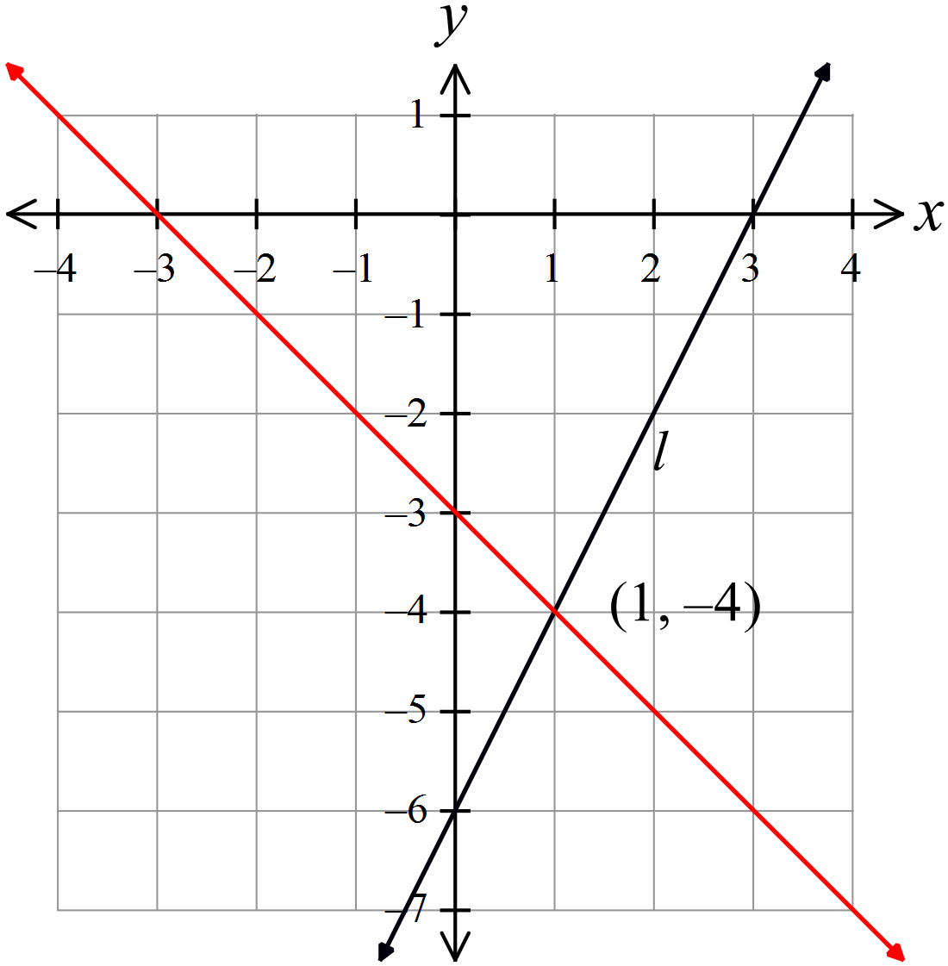  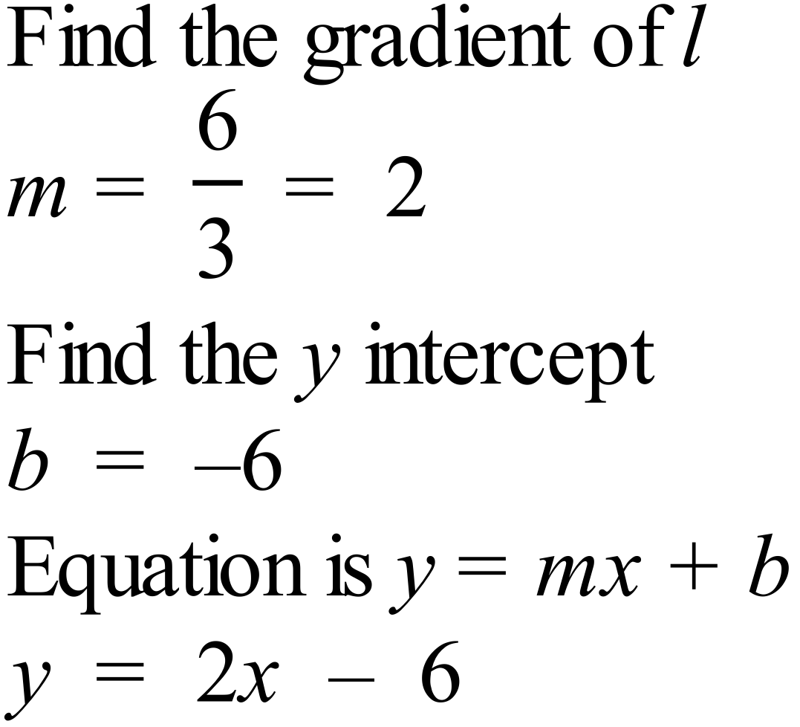 |  |  | D
 | Draw the graph of 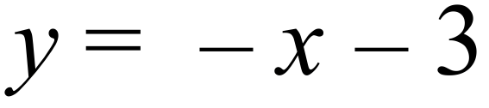  y-intercept = -3, so mark -3 on y axis  Gradient = -1, so go across 1 and down 1 to obtain a second point, and draw the line as shown on graph above.  Point of intersection is (1, -4) |  |  | B
 | 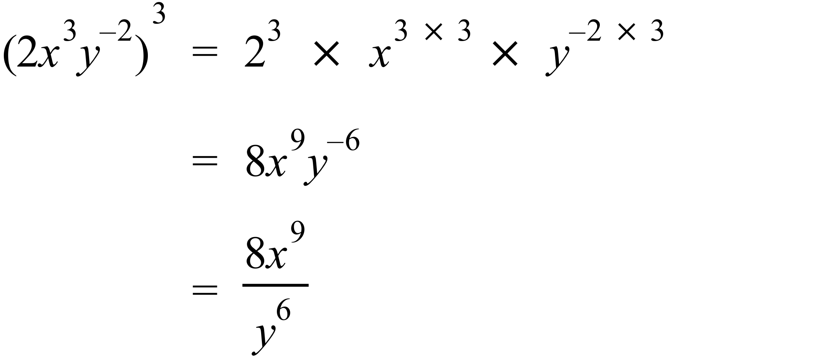 |  |  | B
 | Open circle on -3 indicate 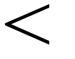 and closed on 2 indicates   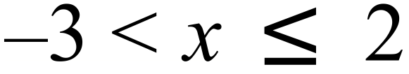 |  |  | A
 | It is bimodal as two scores occurred four times which is more than any other score. |  |  | A
 | Median = average of 9th and 10th scores = 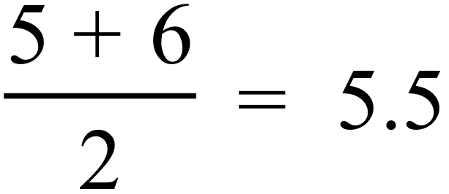  Mean = 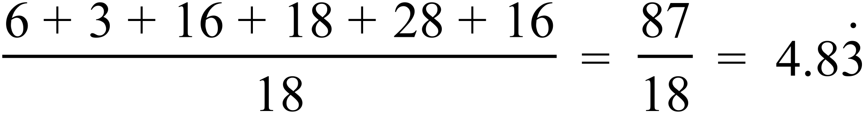  Mode = 4 and 7  Range is from 2 to 8, ie 6  Statement D is inaccurate as the most common (mode) is both 4 and 7, not just 7. |  |  | D
 | There are 18 data scores altogether, and 4 of these represent groups of four.  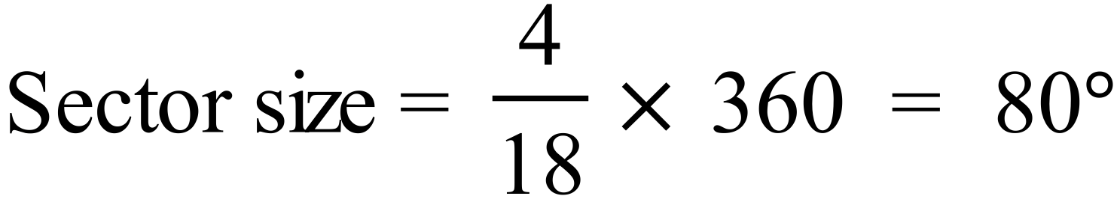 |  |  | D
 | Mean : Since two scores greater than the mean are added, the mean will change.  Median: Since the mode is 14 with 3 scores, and the median is 11, the most number of 11’s possible is 2. Since there were an even number of scores, the median came from two 11’s or two other scores with an average of 11. When two scores greater than 11 are added, the median will move to the right, and hence will change.  Mode: Mode is 14 which occurs 3 times, and since the highest score is 9 (minimum) + 6 (range) = 15 there were no 16’s previously, so now there are two 16’s, so 14 remains the mode.  Range : The range was 6, going from 9 to 15, so adding 2 16’s makes it 7, so it changes.  Only the mode doesn’t change. |  |  | C
 | 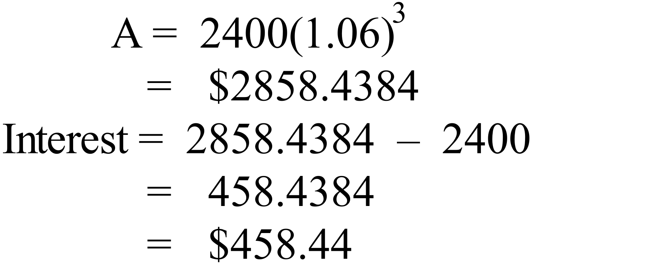 |  |  | C
 | 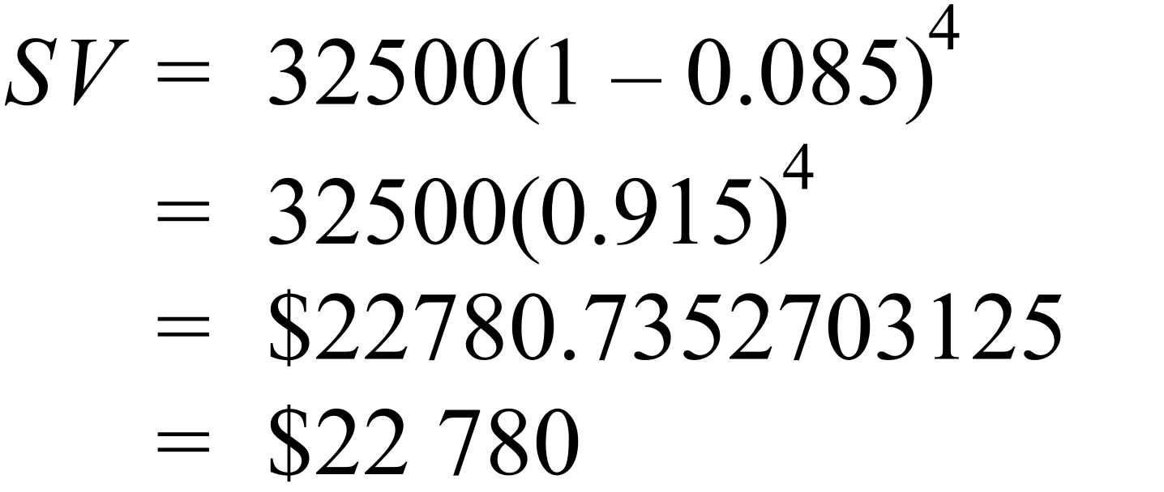 |  |  | B
 | 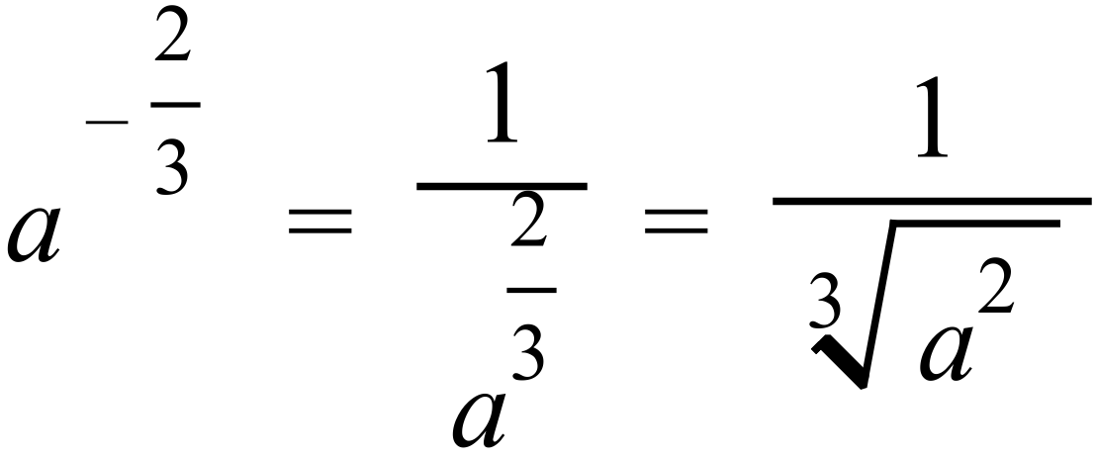 |  |  | A
 | 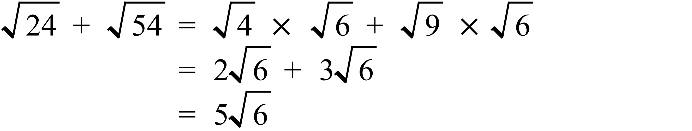 |  |  | A
 | 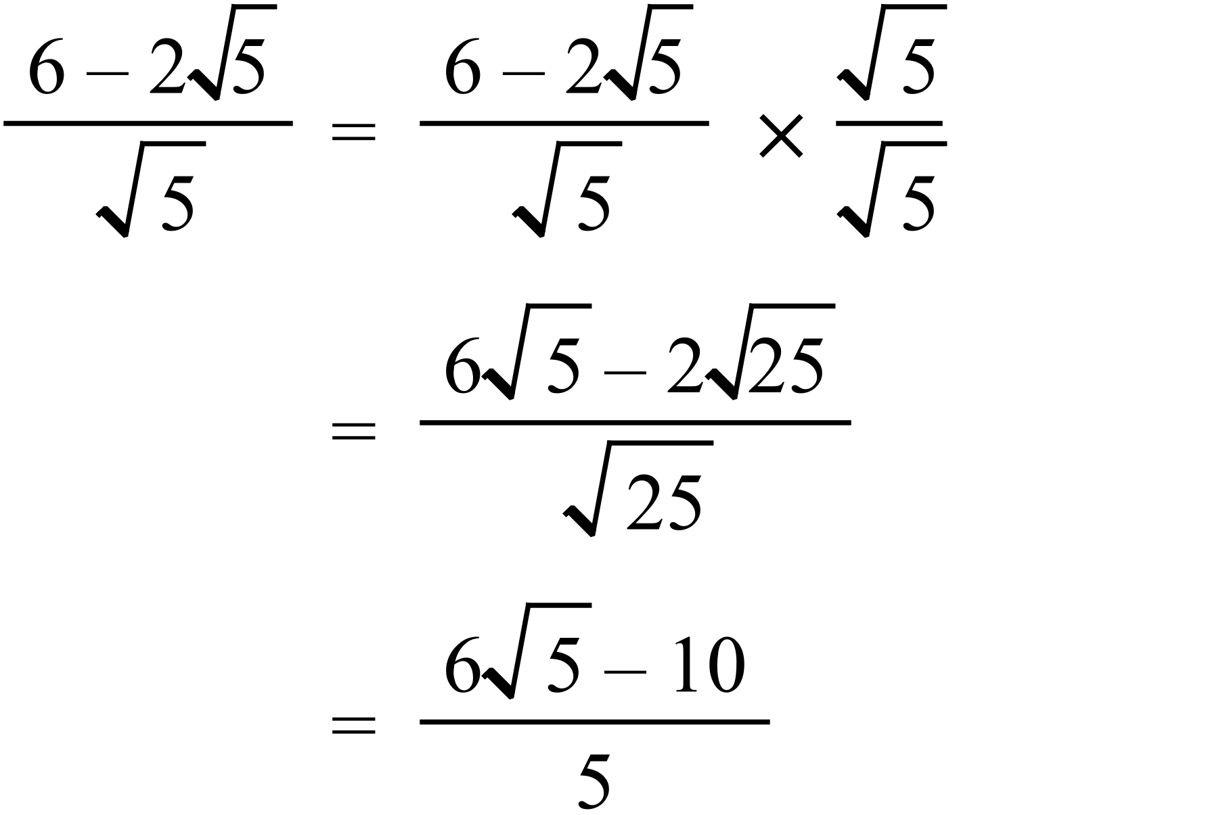 |  |  | D
 | 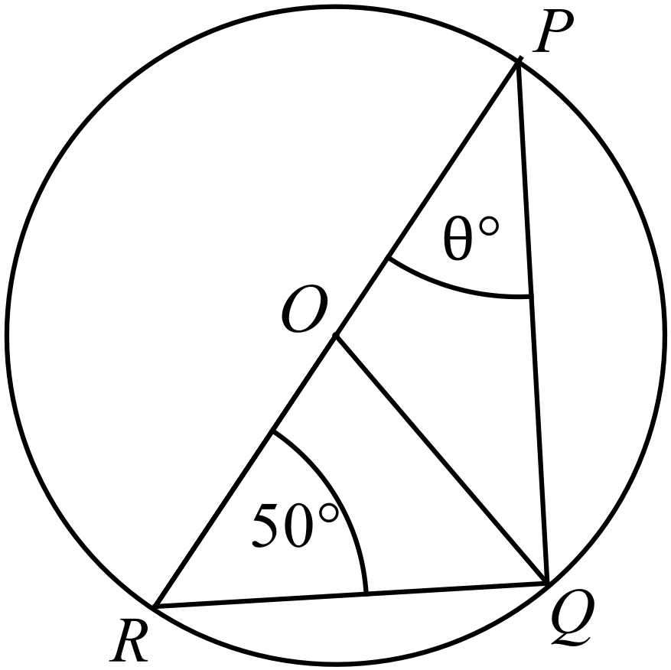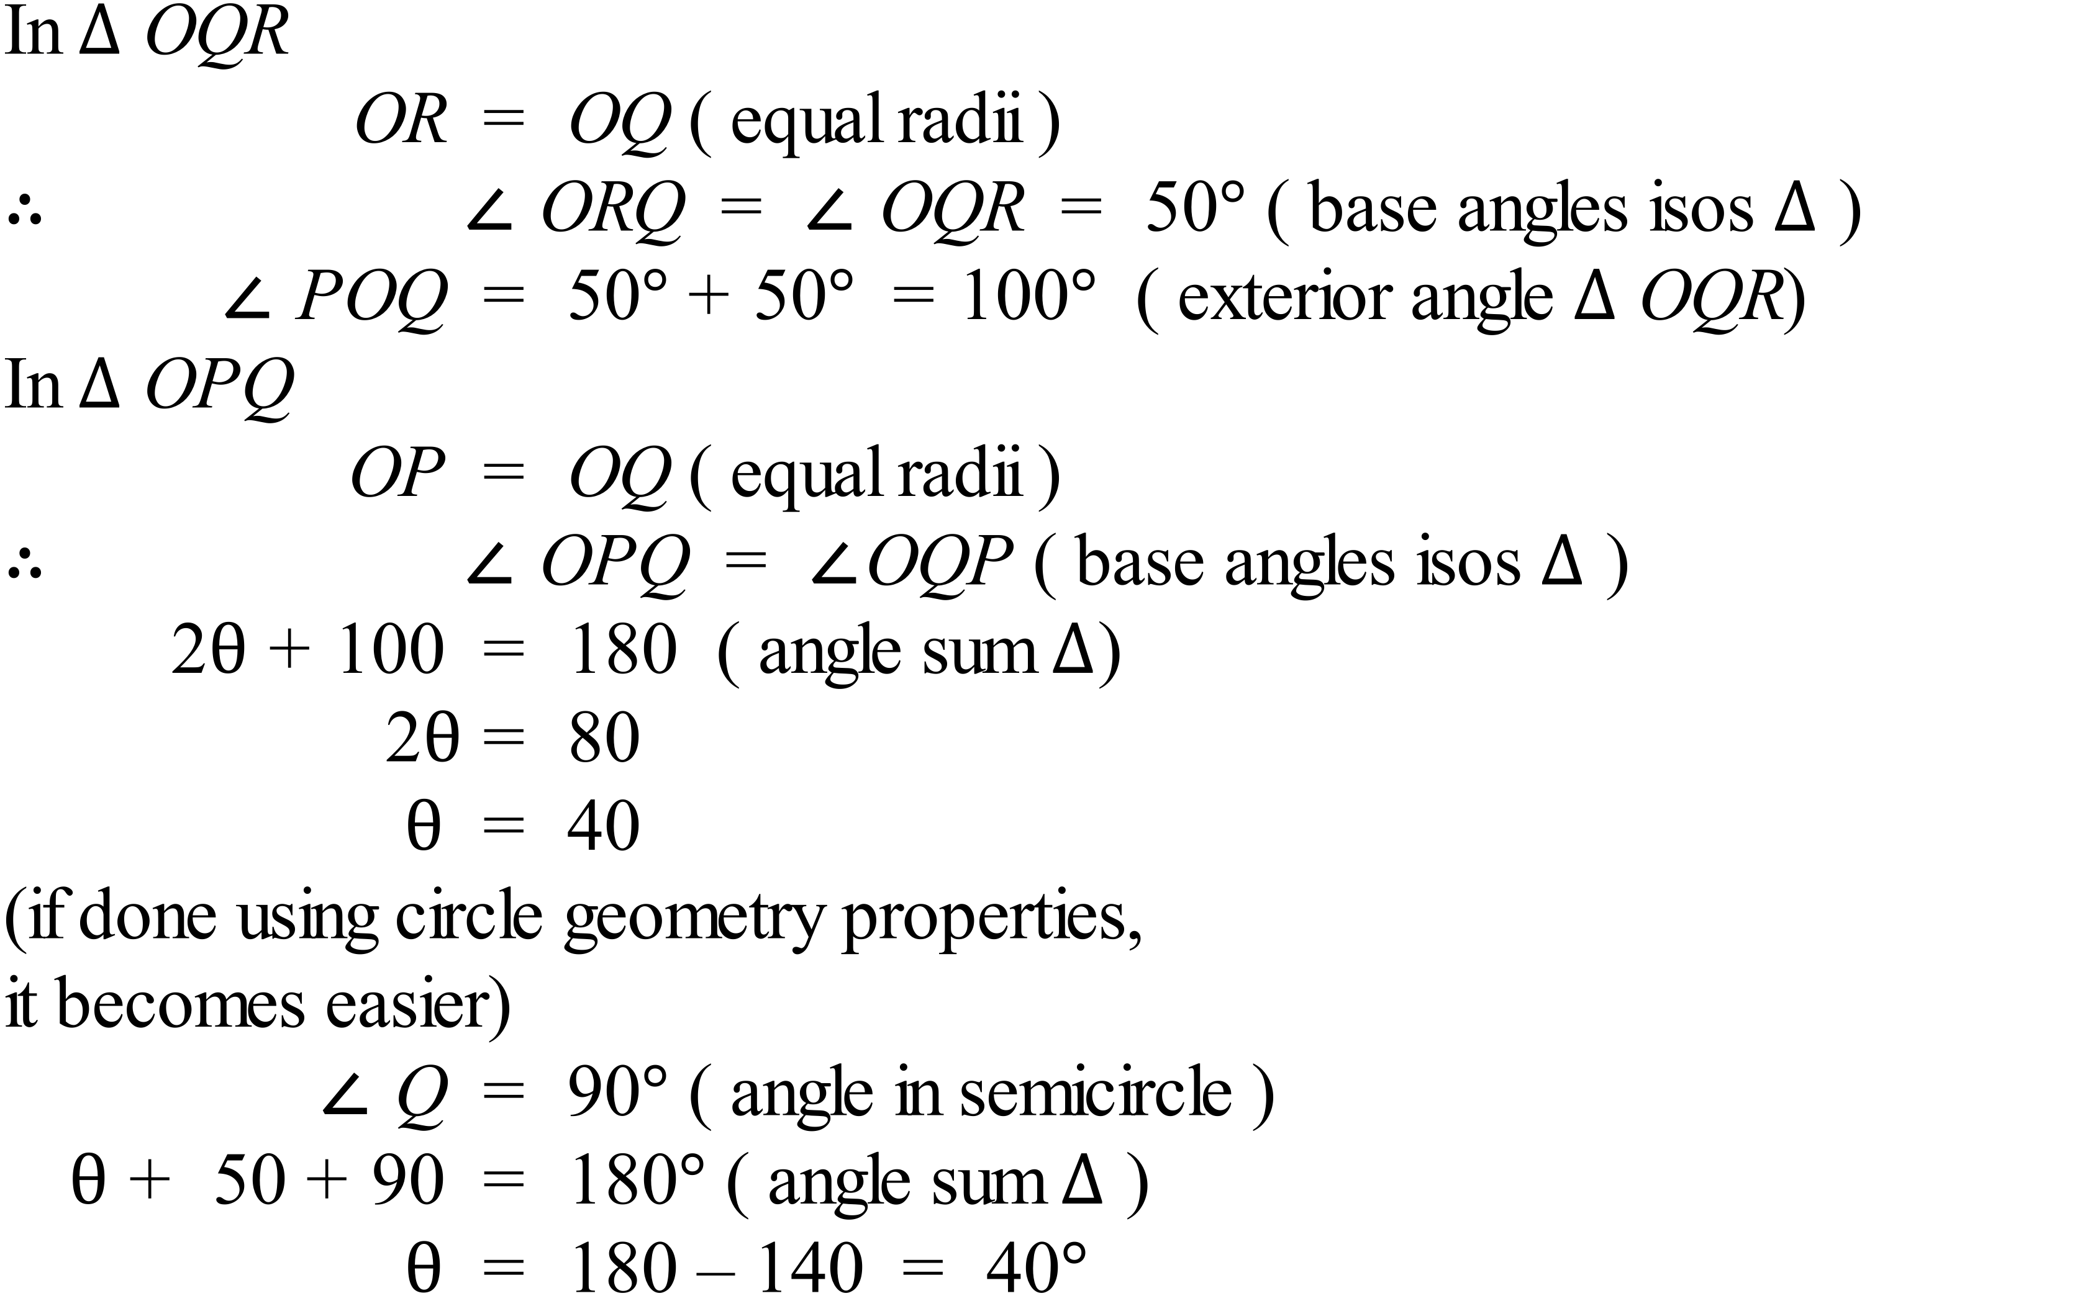 |  |  | B
 | 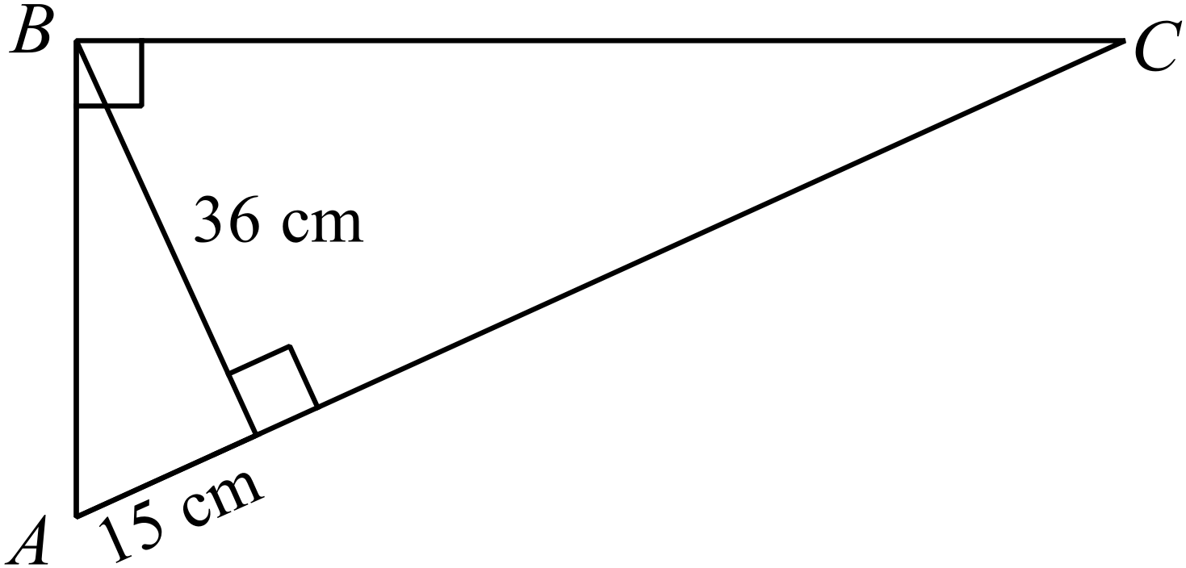  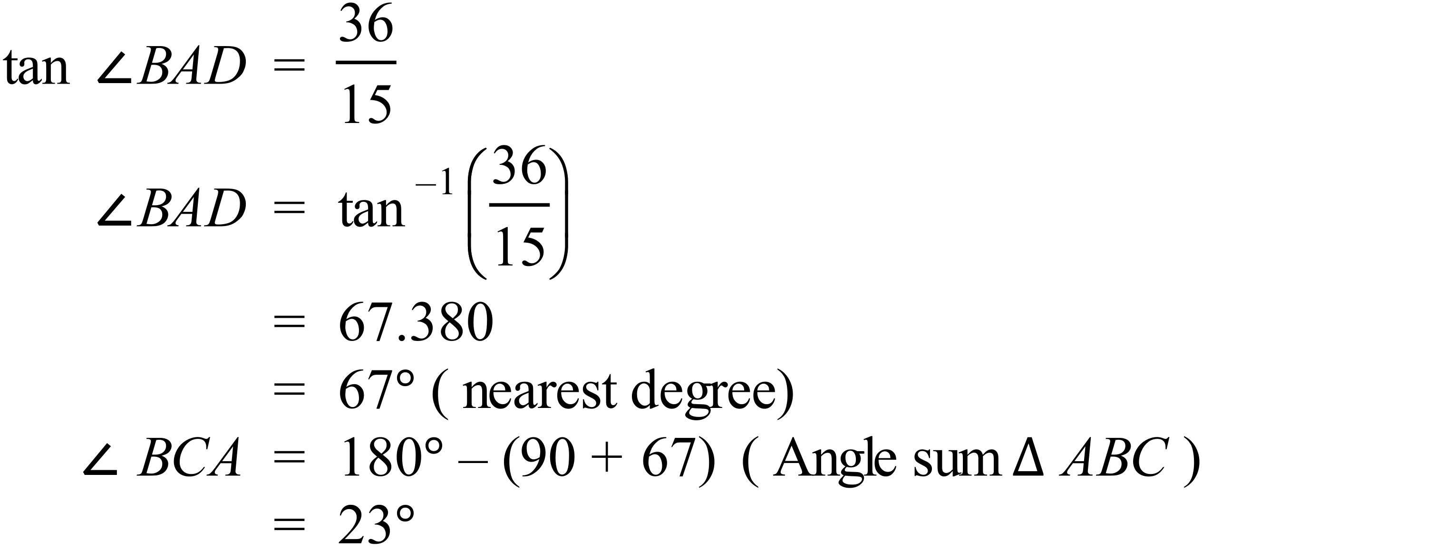 |  |  | A
 | 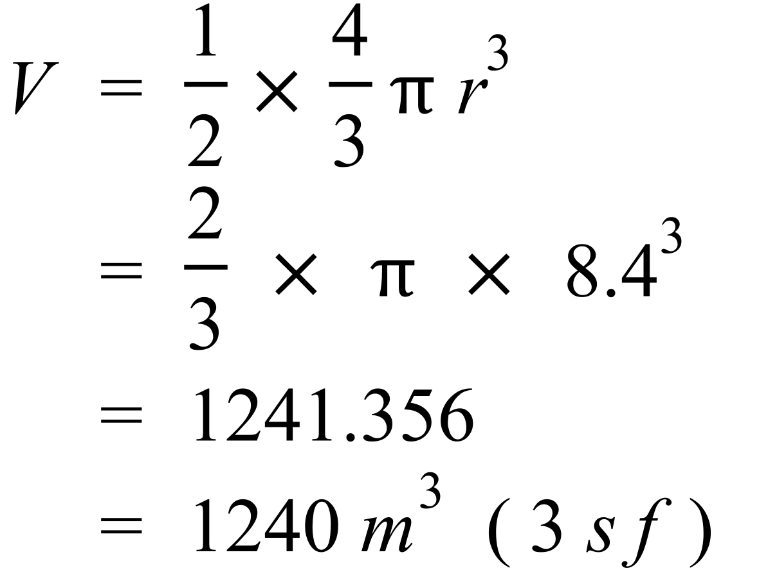 |  |  | C
 | 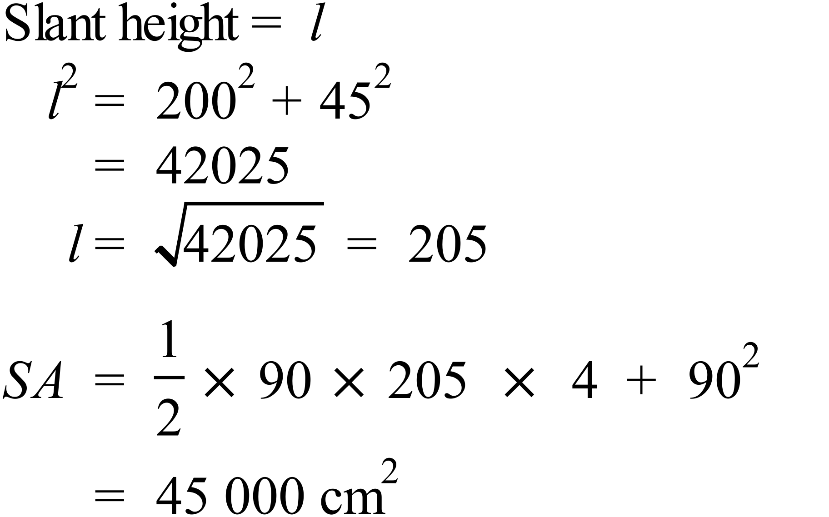 |  |  | D
 | 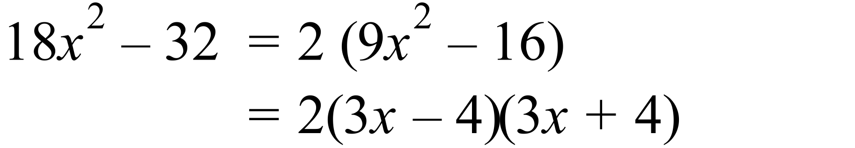 |  |  | B
 | 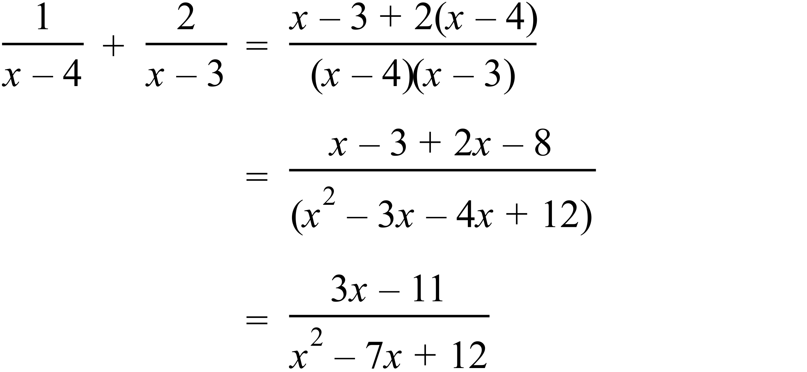 |  |  | D
 | 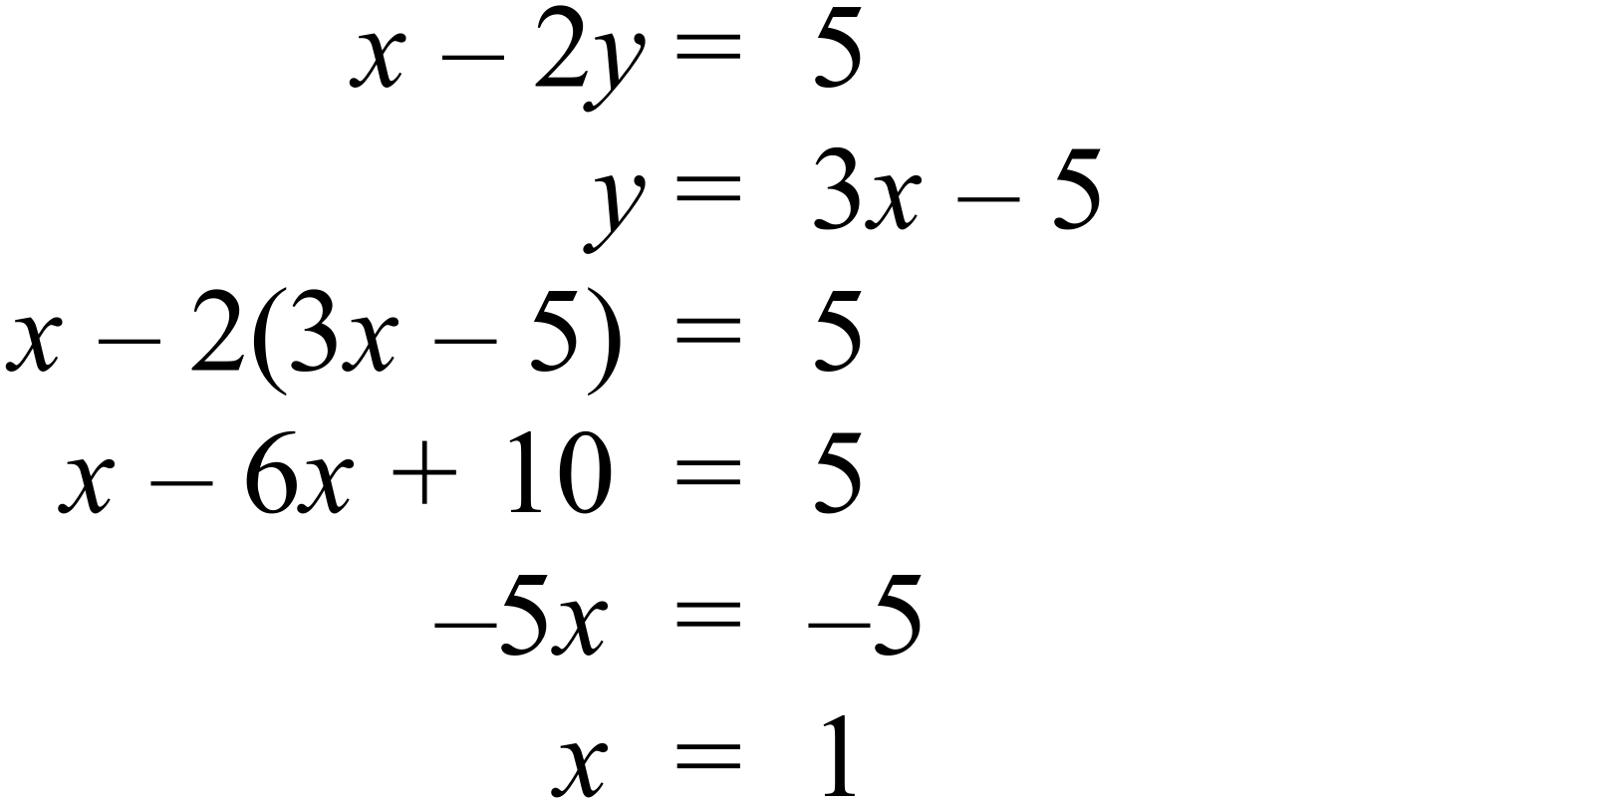 |  |  | C
 | 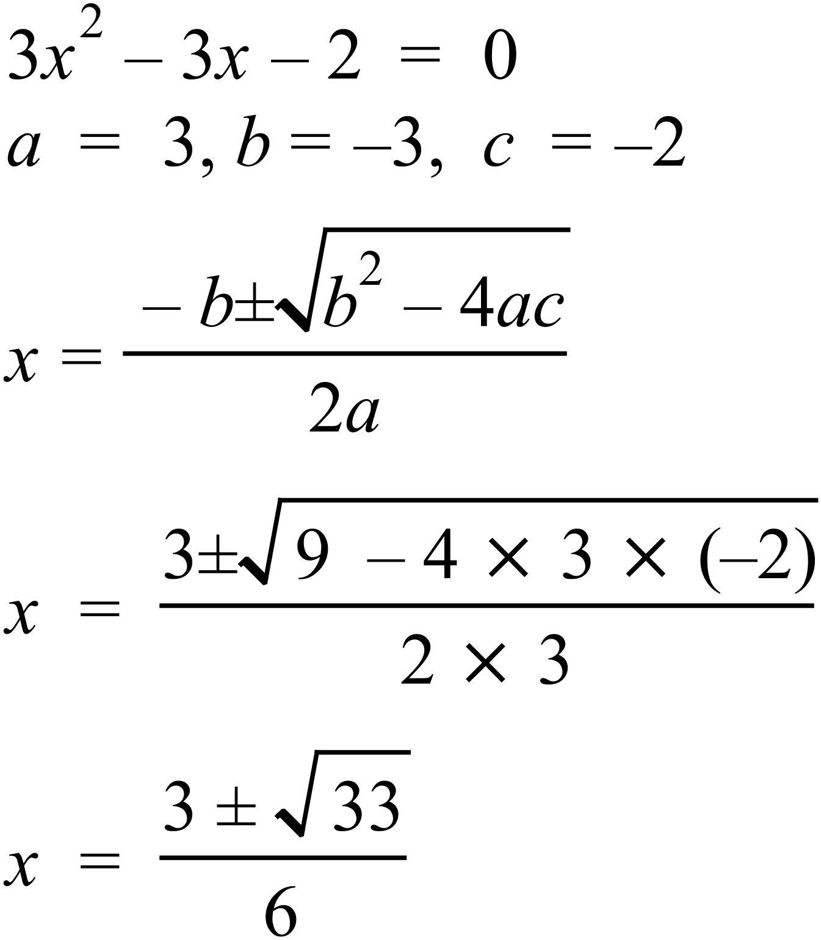 |  |  | B
 | Fastest change is the steepest section of the graph which is between 00:00 and 02:00  Change is 10 m in 2 hours which is 5 m/h. |  |  | A
 | Since concave down, it must be either B or D.  When  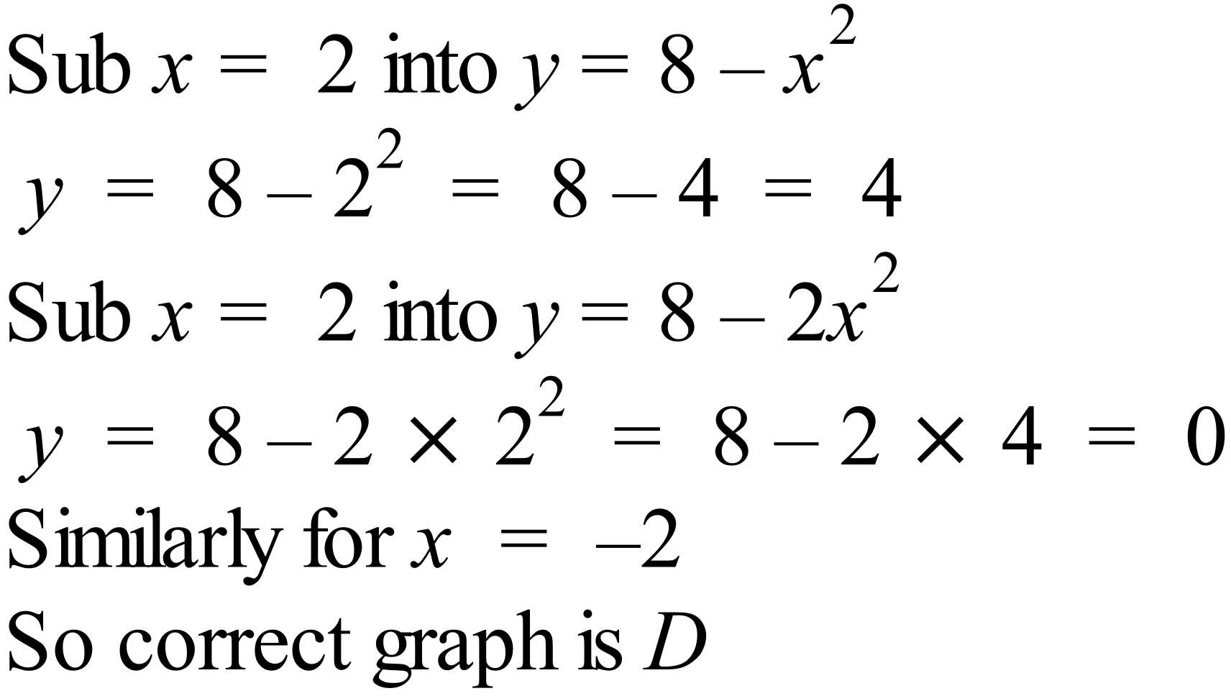 |  |  | D
 | 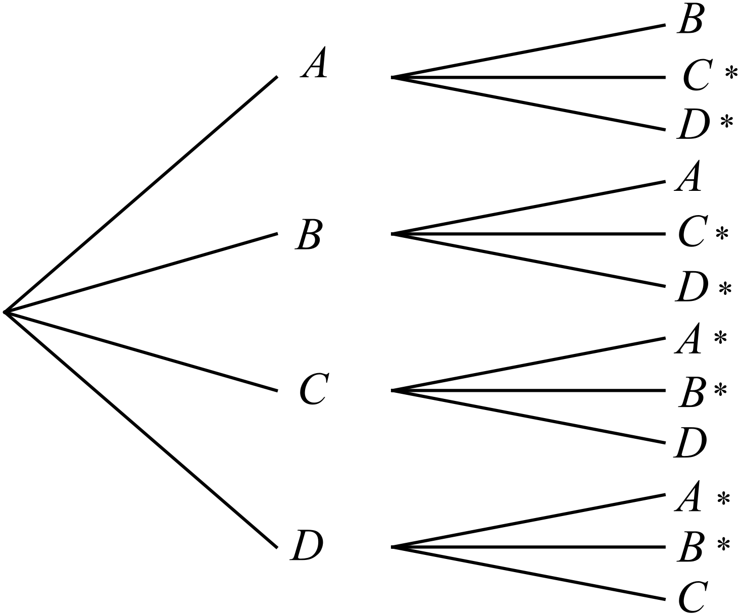  Those which meet the requirement A or B but not both are marked *.  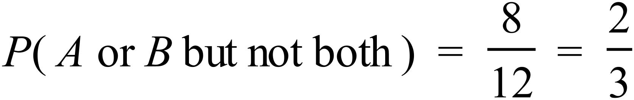 |  |  | B
 | Archery and Golf had 6 who played both.  There were 60 players altogether.  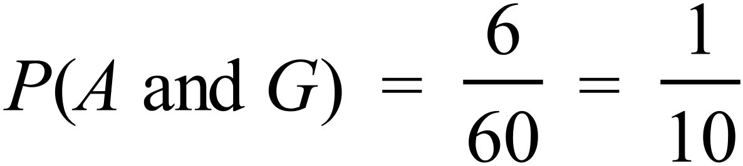  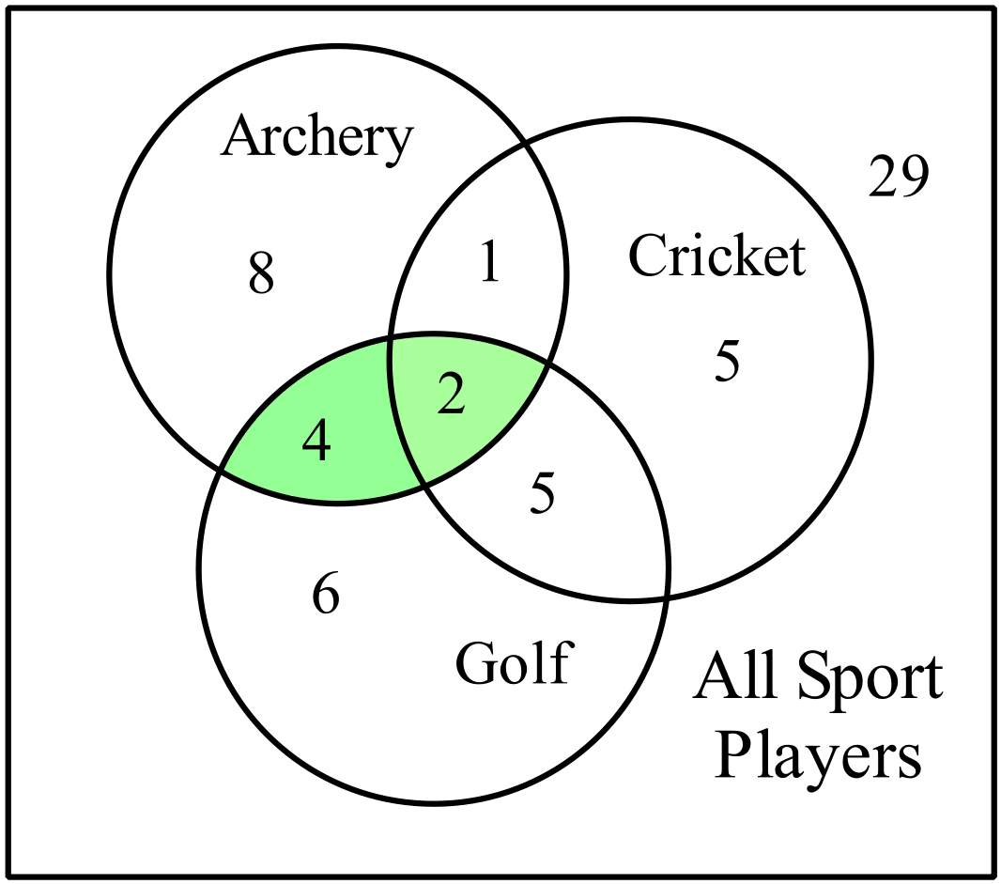 |  |  | C
 | 74 is the lower quartile and 82 is the median, so a quarter of all people lie between these values.  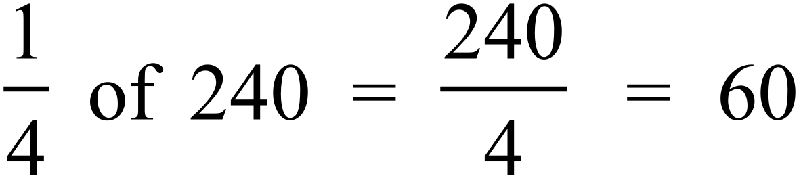 |  |  | A
 | From calculator Standard deviation 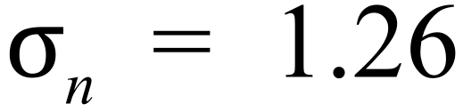 |  |  | C
 | As all scores increase by 2, the mean will increase by 2, and since all increase by the same amount, the spread will be the same, so the standard deviation will not change.  New mean = 88.2 + 2 = 90.2 New SD = Old SD = 4.3 |  |  | D

School Name
Year 10 Half Yearly Examination
Advanced Mathematics Course 2016
Multiple Choice Section Answer Sheet

Name ________________________________ Teacher ________________________

Completely fill the response oval representing the most correct answer.
Use a black or blue pen or 2B pencil.

21. A B C D
22. A B C D
23. A B C D
24. A B C D
25. A B C D
26. A B C D
27. A B C D
28. A B C D
29. A B C D
30. A B C D
31. A B C D
32. A B C D
33. A B C D
34. A B C D
35. A B C D
36. A B C D
37. A B C D
38. A B C D
39. A B C D
40. A B C D

41. A B C D
42. A B C D
43. A B C D
44. A B C D
45. A B C D
46. A B C D
47. A B C D
48. A B C D
49. A B C D
50. A B C D
51. A B C D
52. A B C D
53. A B C D
54. A B C D
55. A B C D
56. A B C D
57. A B C D
58. A B C D
59. A B C D
60. A B C D

Year 10 | WME Solutions  Advanced Mathematics  Half Yearly | Calculator Allowed
Section 2 Part B Longer Answer Section
ANSWERS
 |  |  | Marks

61. | a) | 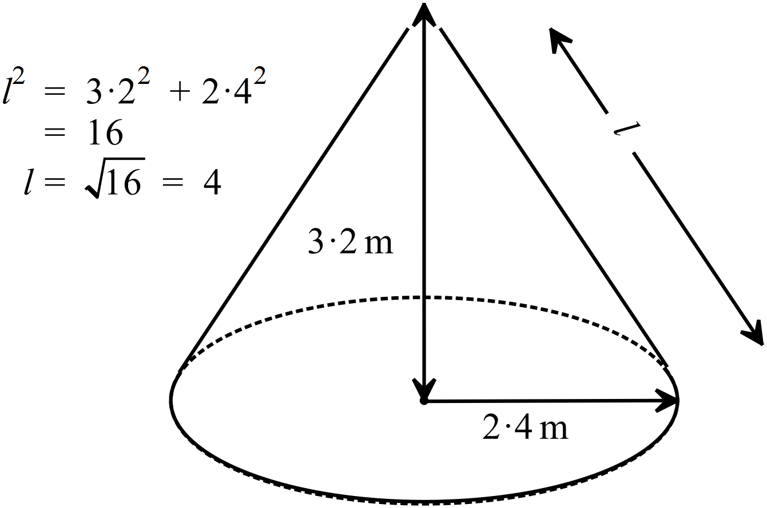 | 1 mark for correct answer
 | b) | 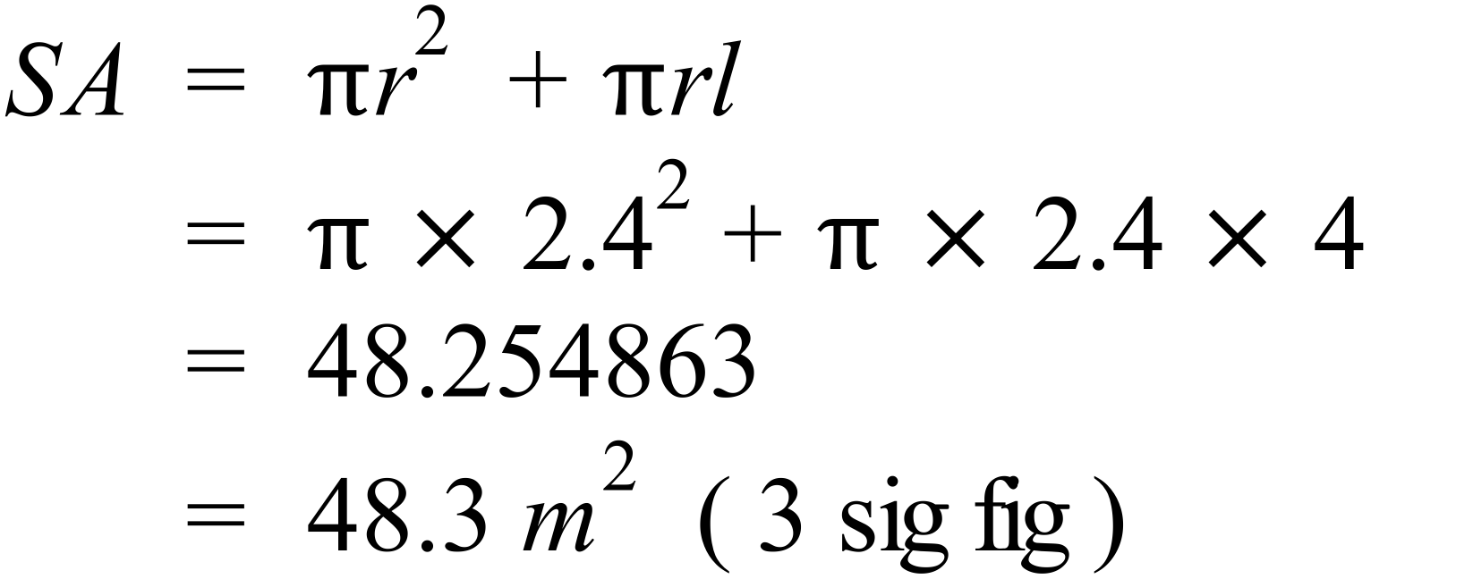 | 1 mark for correct answer
62. | a) | 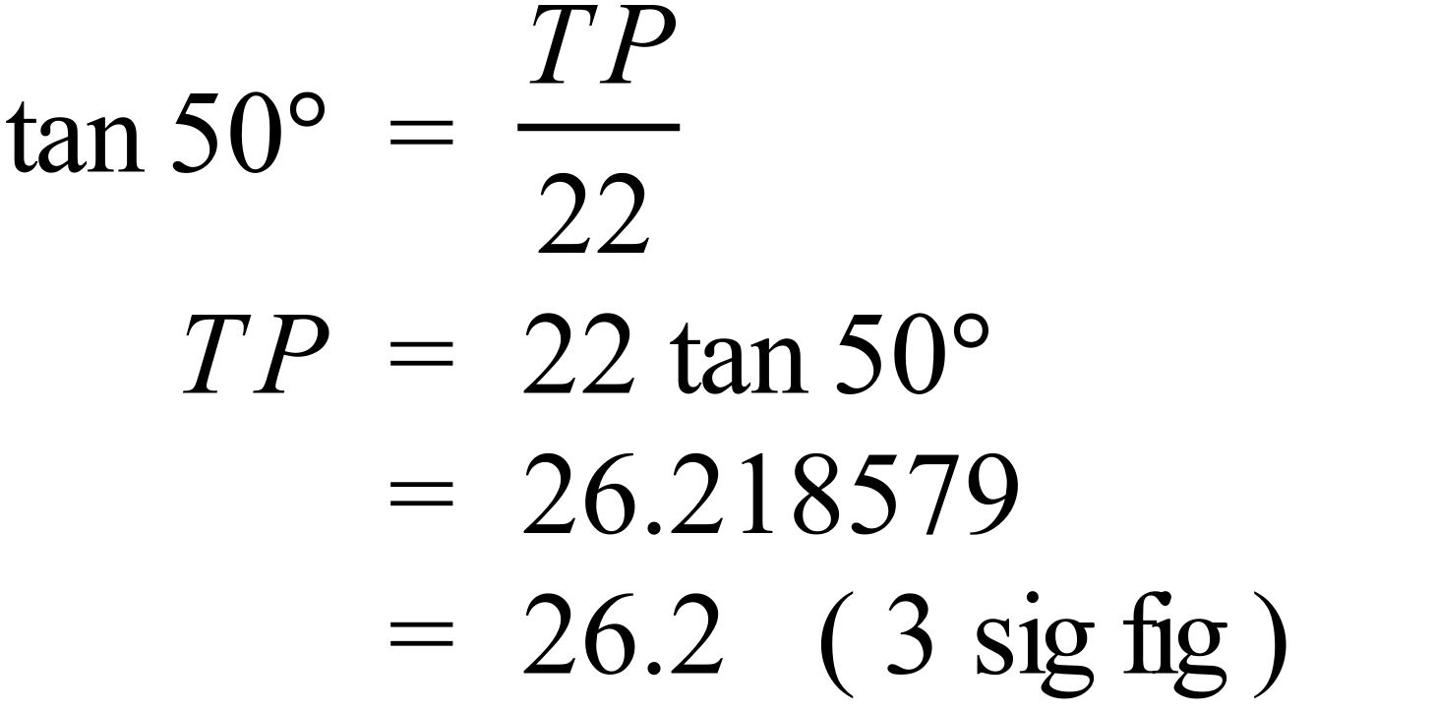 | 1 mark for correct answer
 | b) | 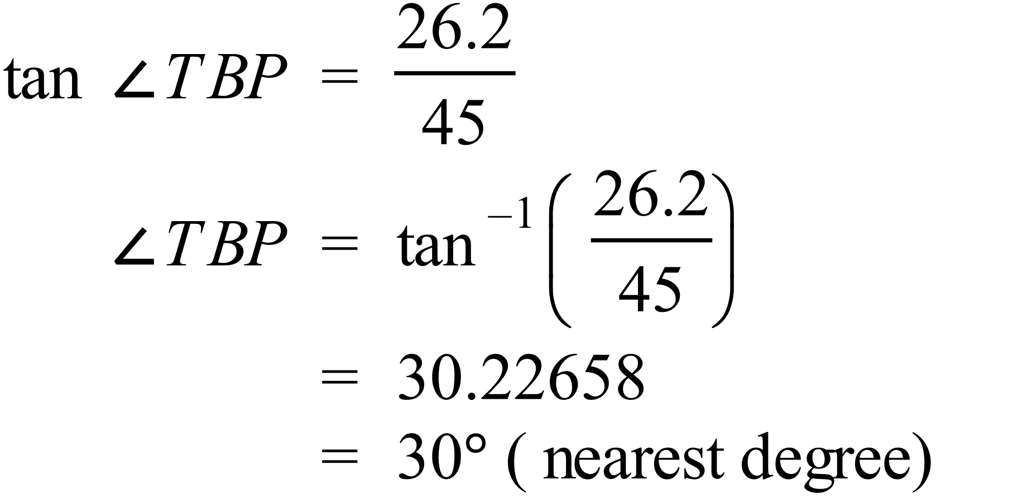 | 1 mark for correct answer
63. | a) | 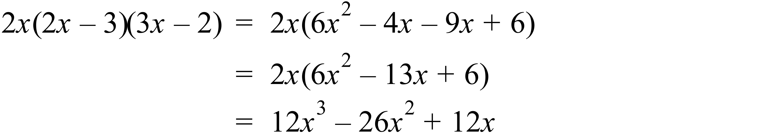 | 1 mark for correct answer
 | b) | 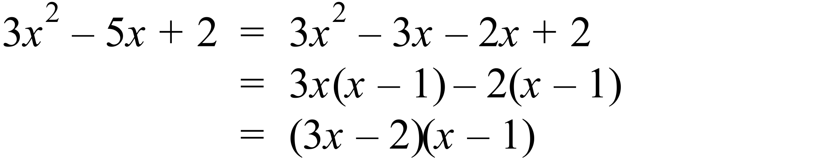 | 1 mark for correct answer
 | c) | 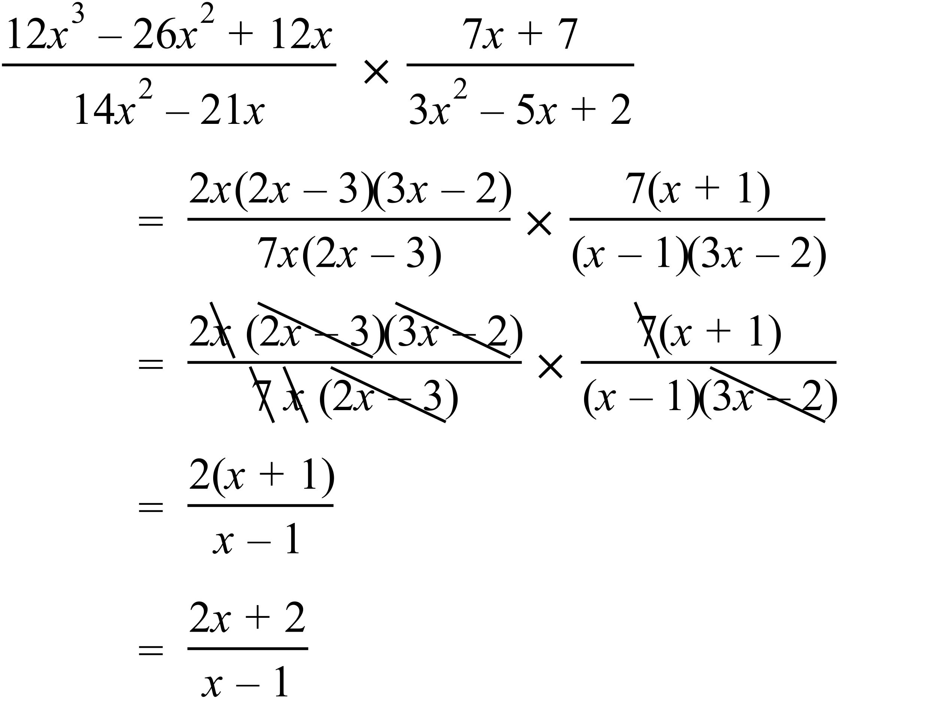 | 1 mark for correct answer in either factorised or expanded form
64. |  | 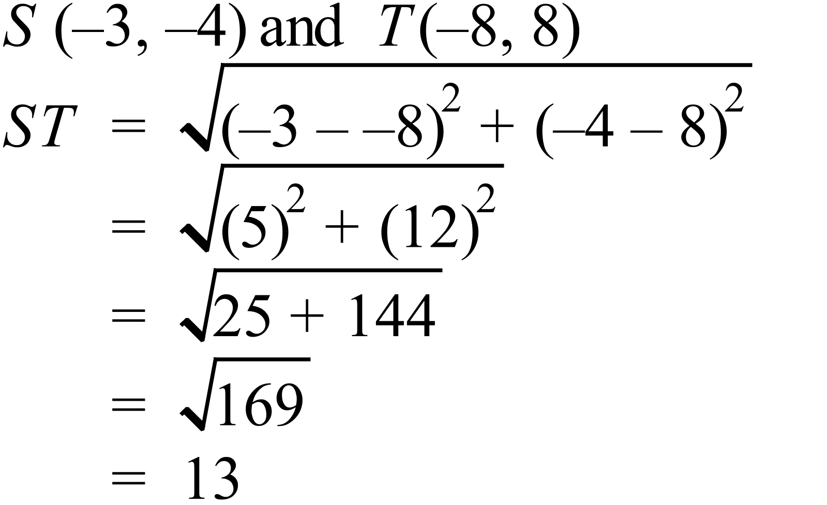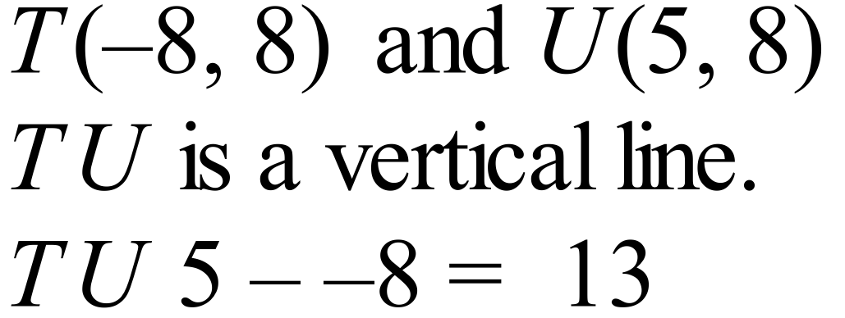  So ST = TU = 13 units,  Hence the triangle is isosceles. | 2 marks for any correct proof, which includes finding at least two distances and showing them equal.  A diagram alone will not suffice unless calculation has been done using Pythagoras to find distances and show equal.  1 mark for worked solution with a minor error, or which is not complete e.g. finding one distances only
65. | a) | 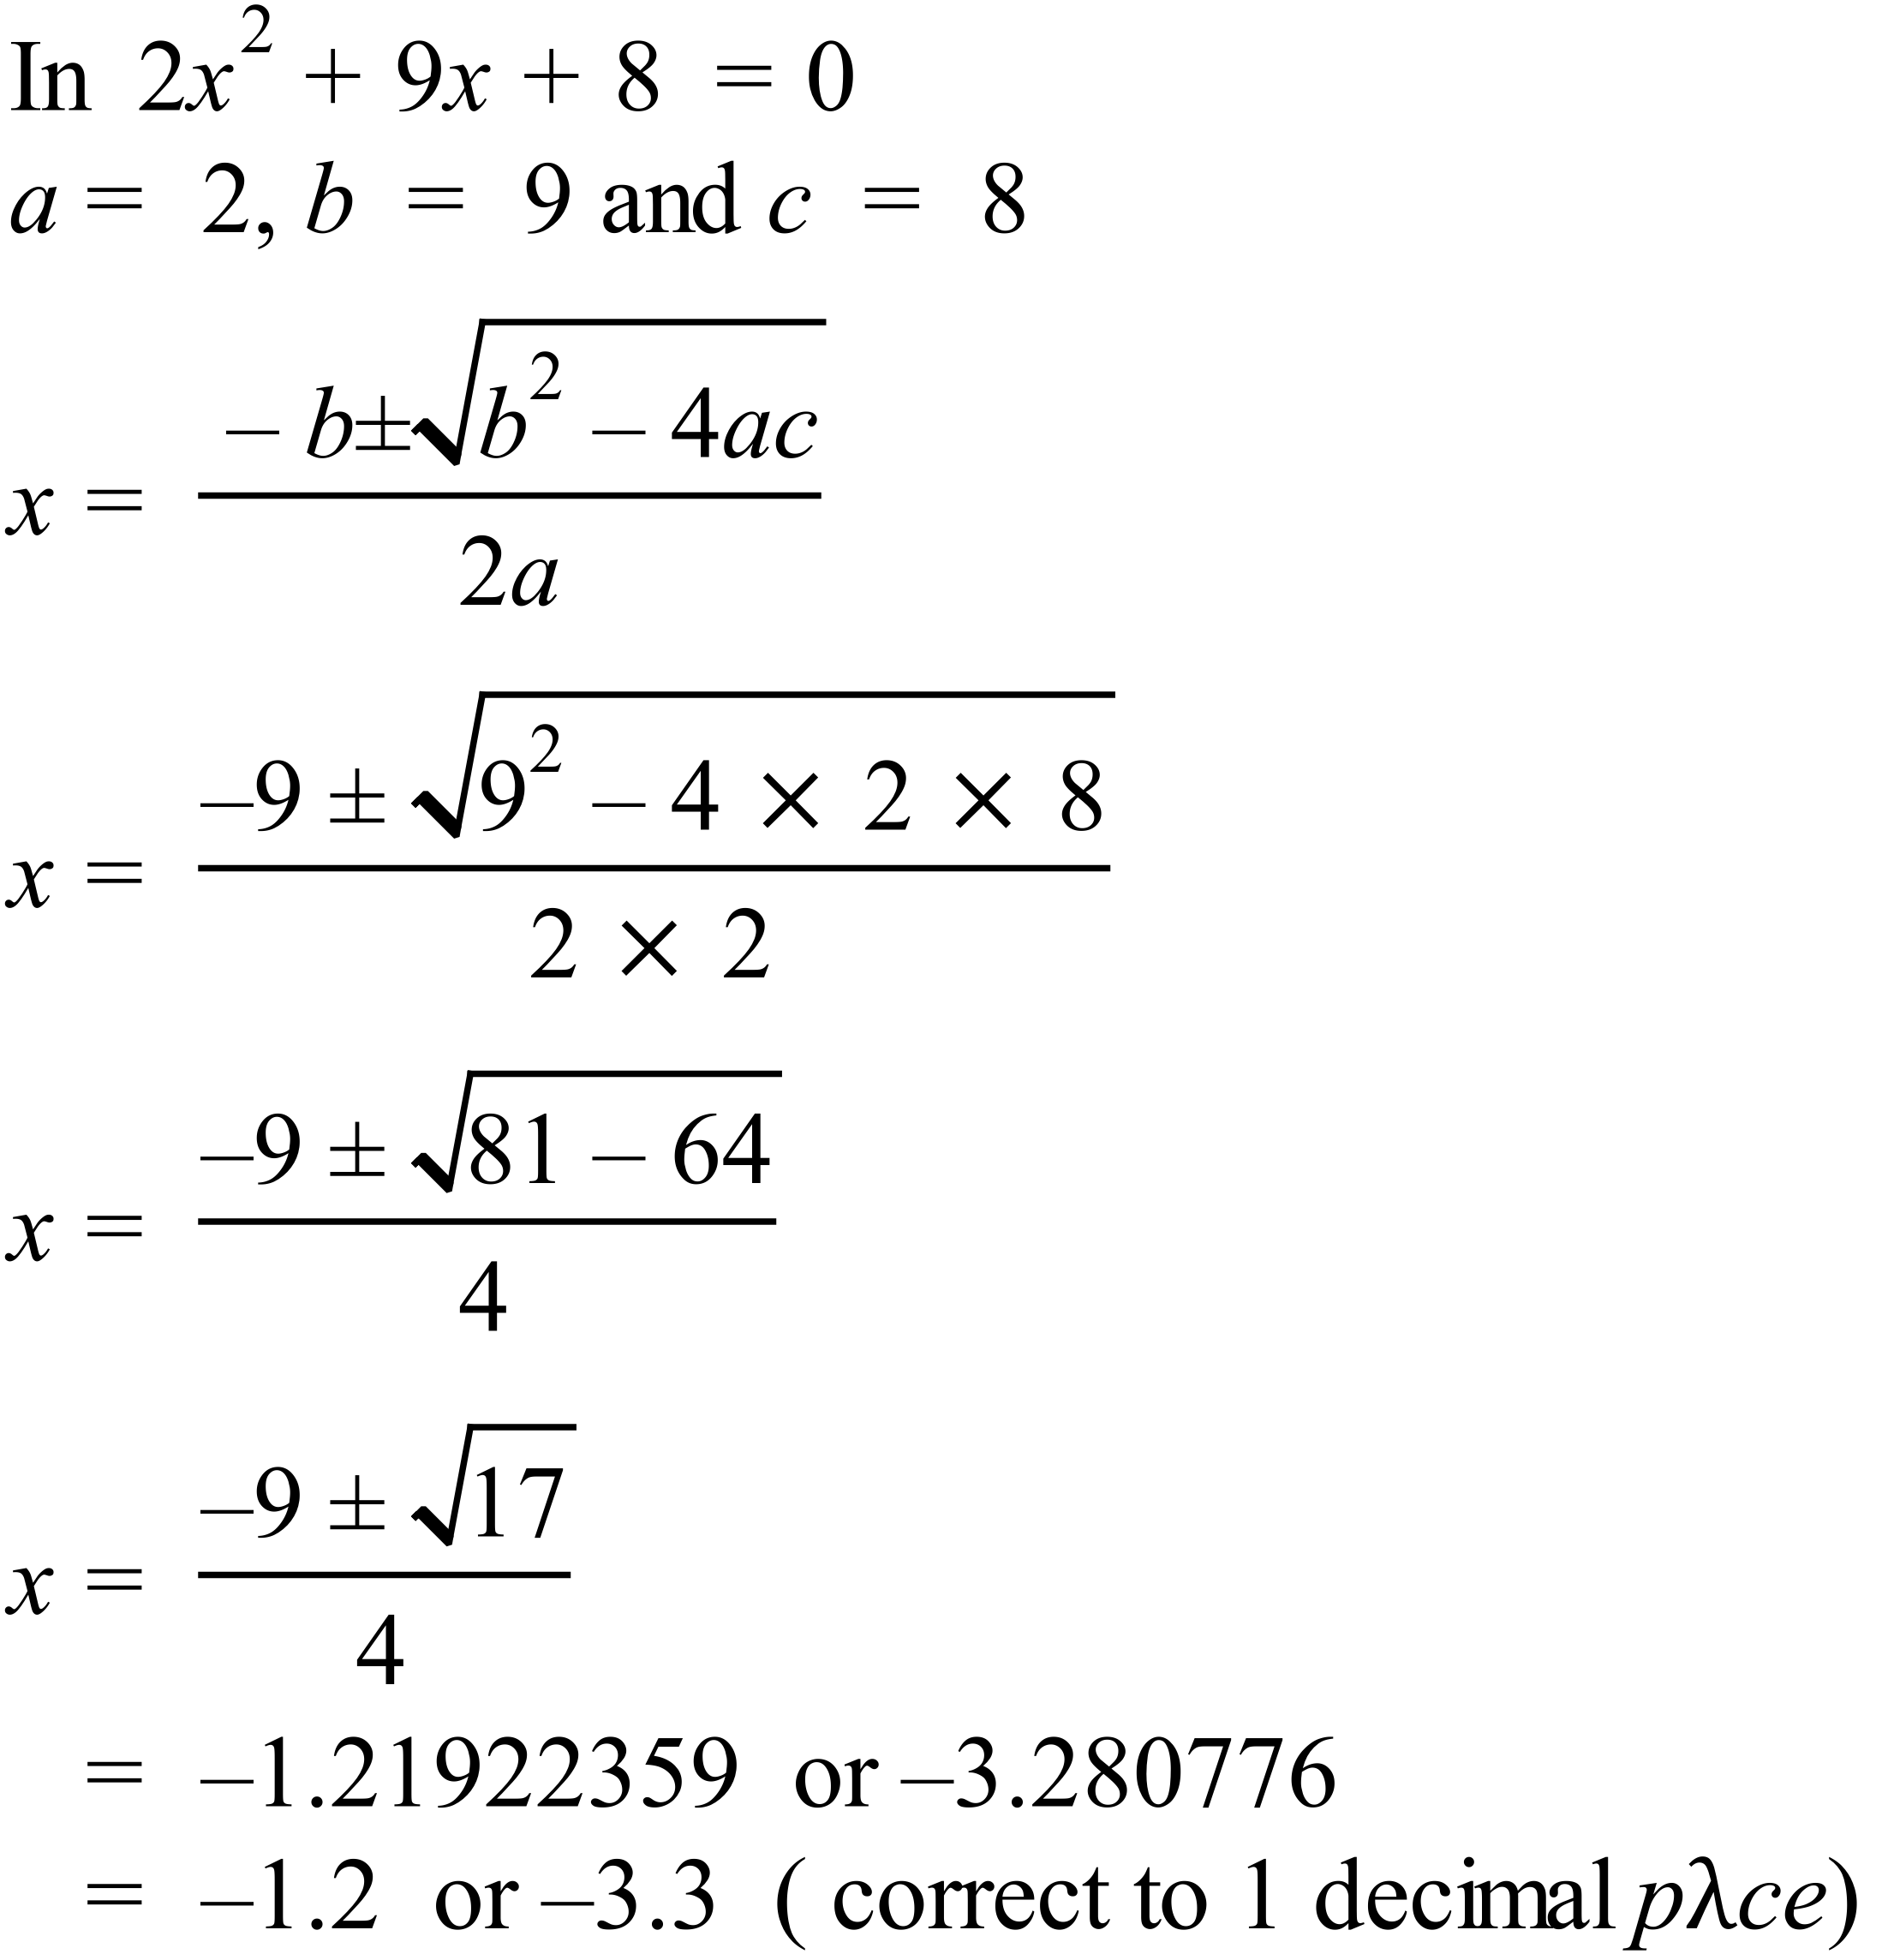 | 2 marks for 2 correct answers.  1 mark for one correct answer or for working with a minor error that leads to incorrect answers.
 | b) | 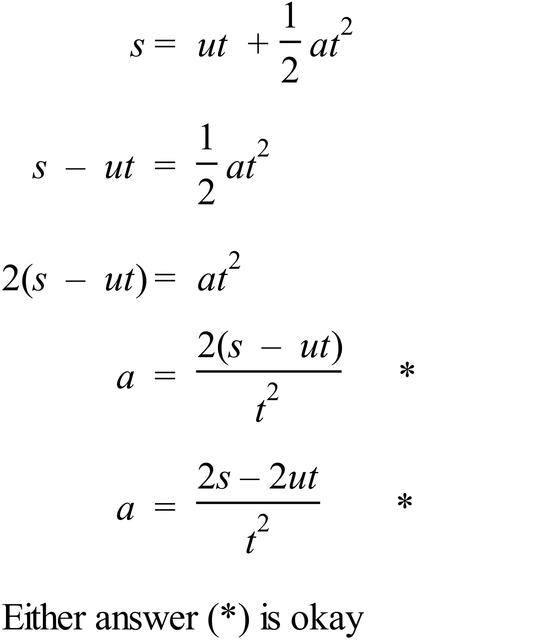
66. |  | 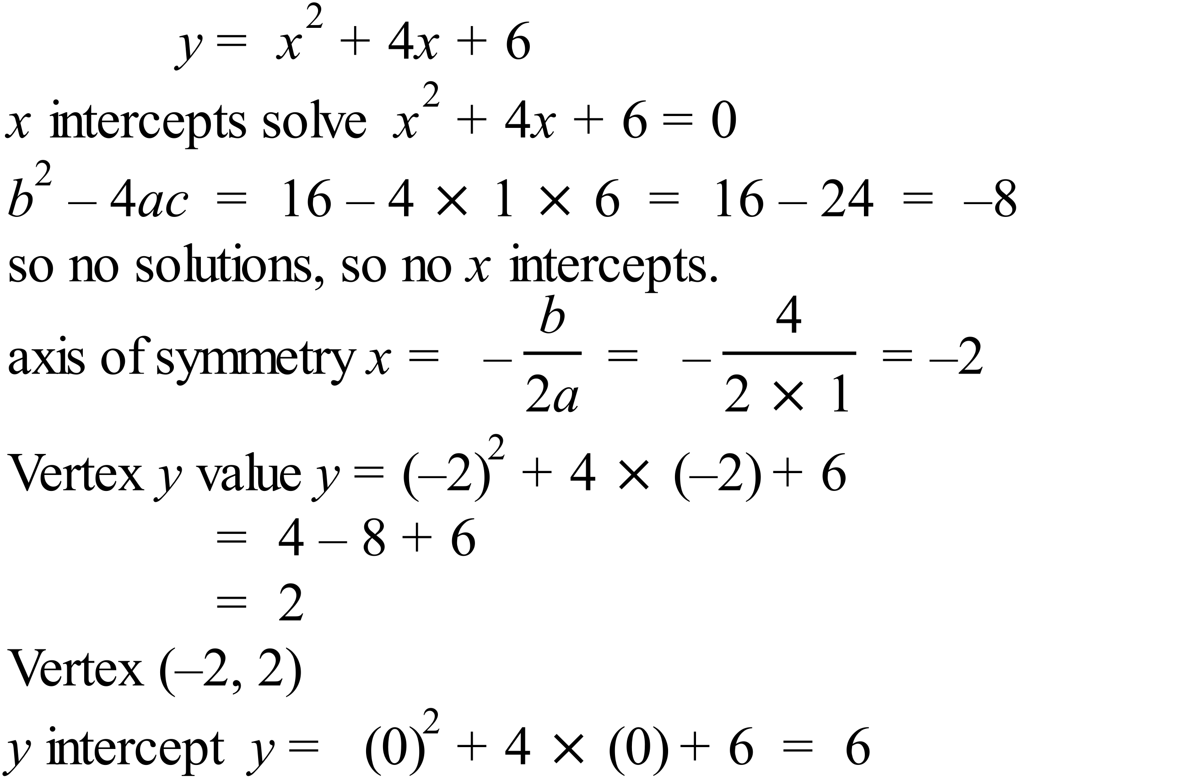  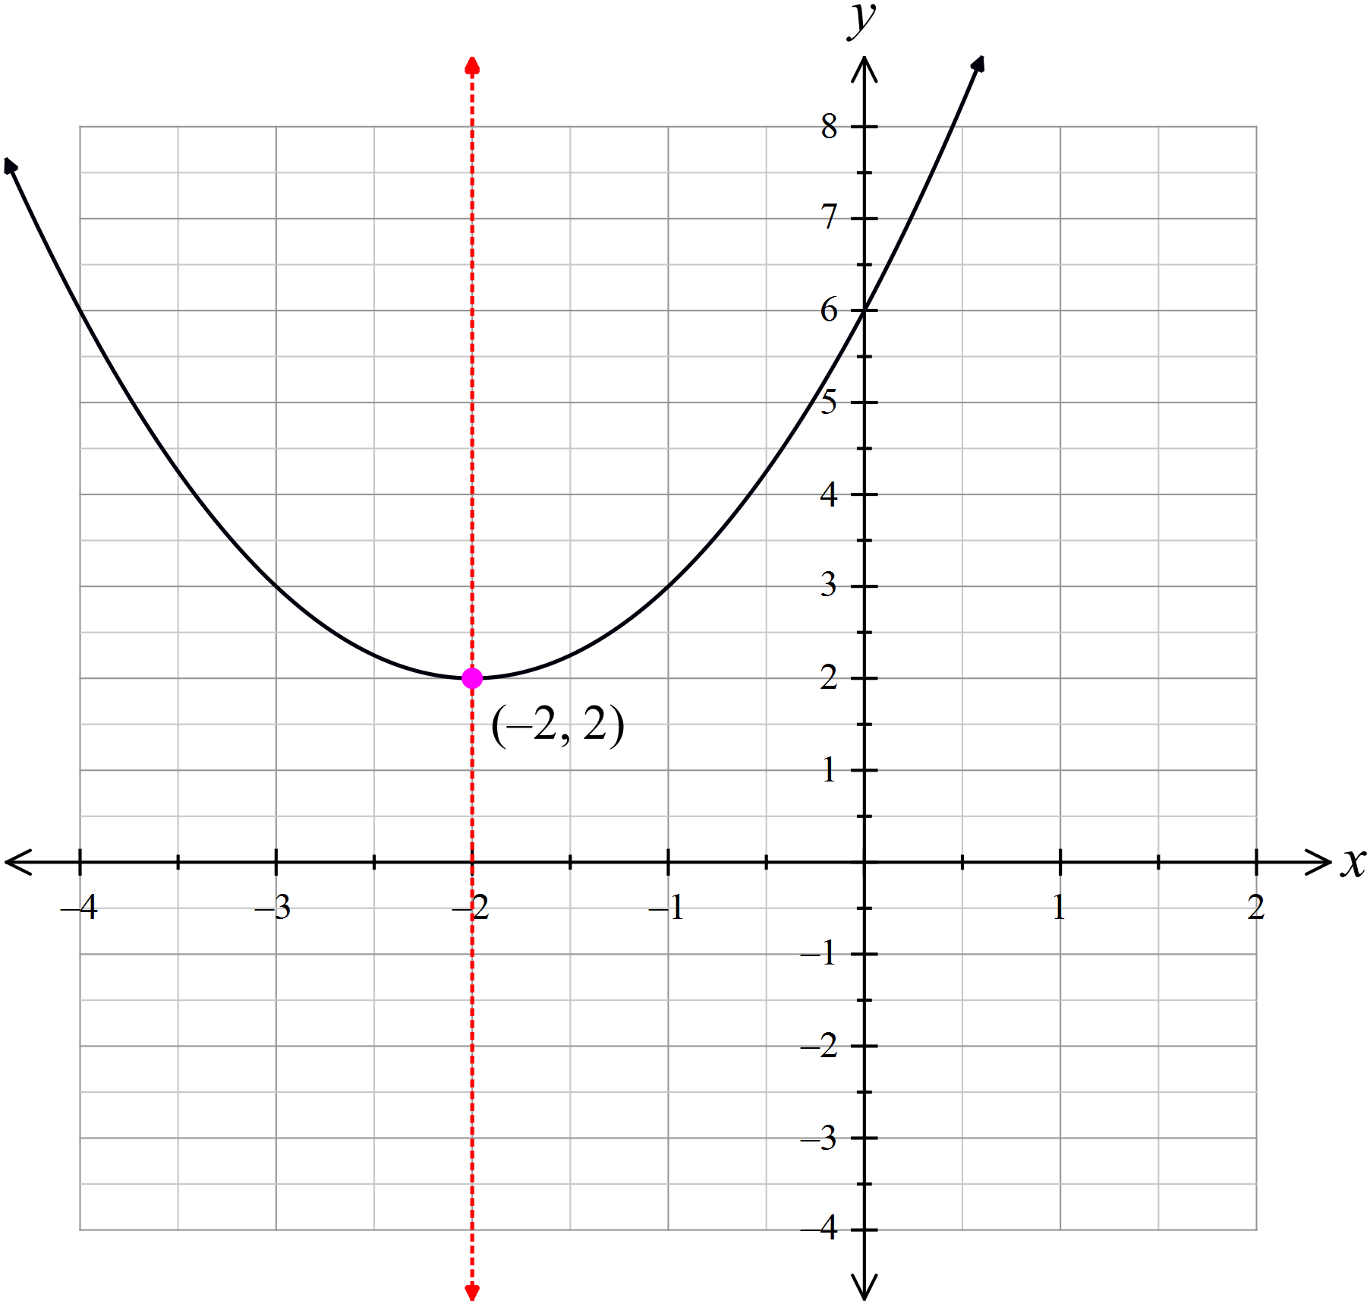 | 3 marks for a graph including  - correct shape (concave up parabola),  - correct axis of symmetry and vertex and  - correct y intercept (and no x intercepts).  2 marks for correct working with a minor error and graph drawn correctly from this,  or 2 marks for correct graph with axis, vertex or intercept missing.  1 mark for some working towards obtaining the graph, or graph with more than one error or missing feature.

67. | a) | 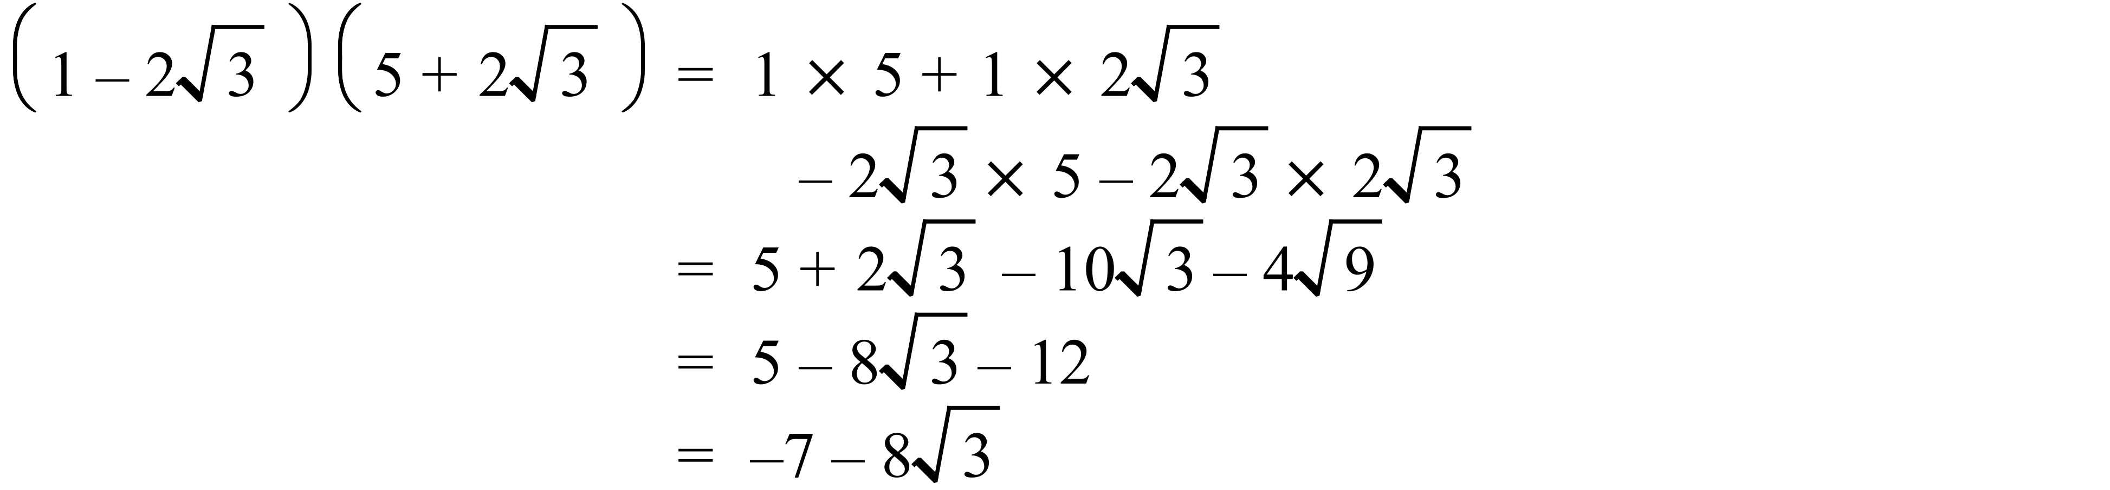 | 1 mark for correct answer
 | b) | 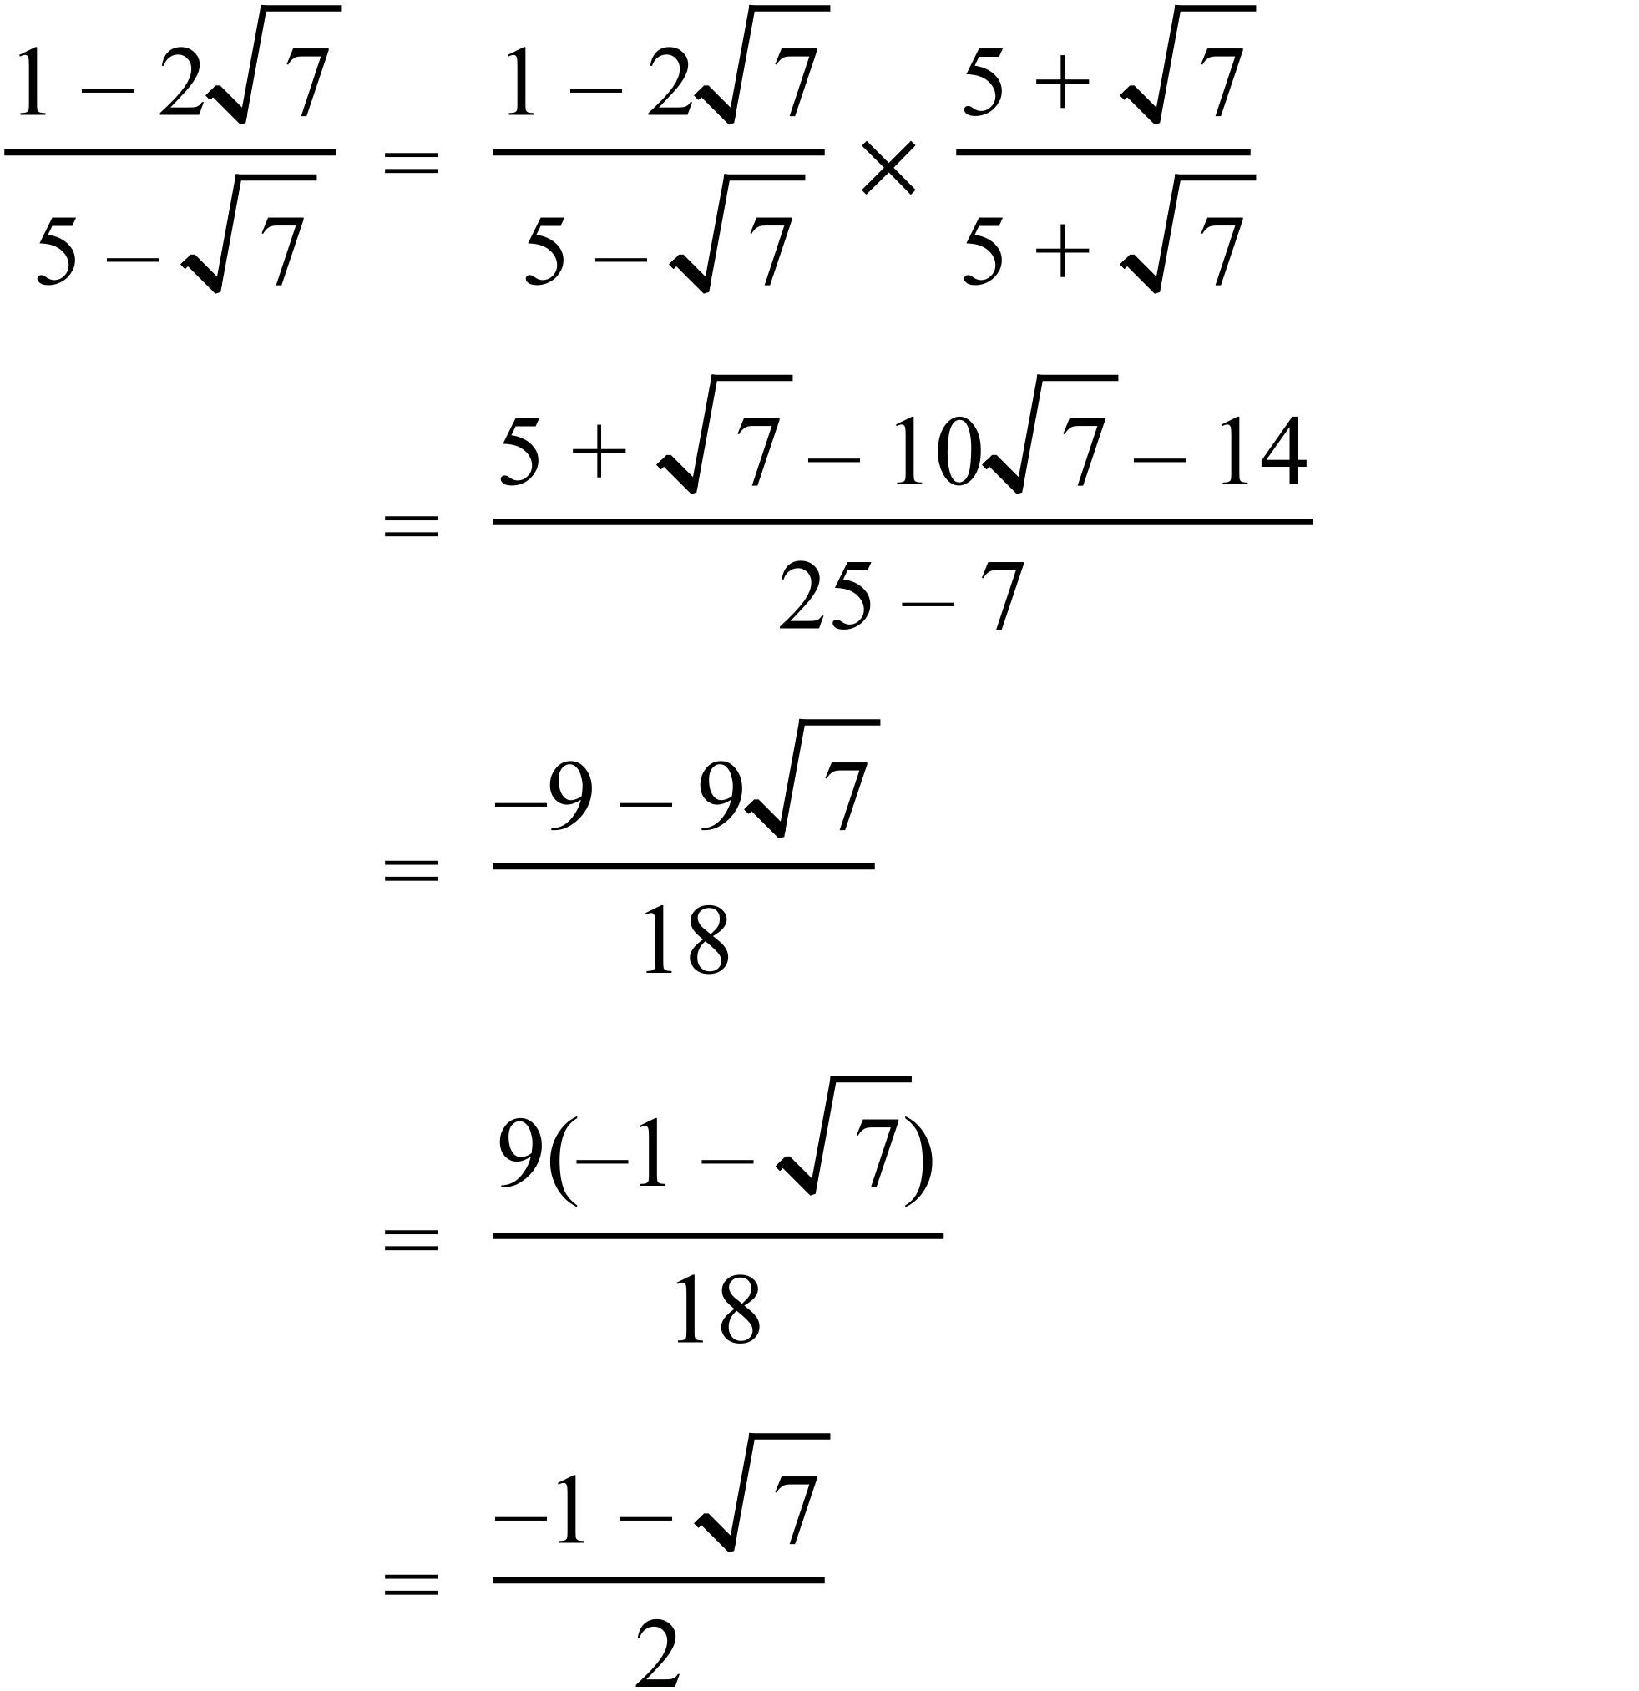 | 2 marks for correct answer, in simplified form  1 mark for worked solution with a minor error, or which is not complete but has substantial correct working
68. | a) | 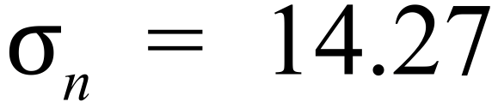  which is bimodal with few values around the centre of the distribution. | 1 mark for the correct standard deviation
 | b) | The shape of the distribution is positively skewed. | 1 mark for the correct term

